**How to Set up a shared Calendar in Outlook**

1. Navigate to **Calendar Folder** on outlook,right click on **Calendar** tab and select **New Calendar.**

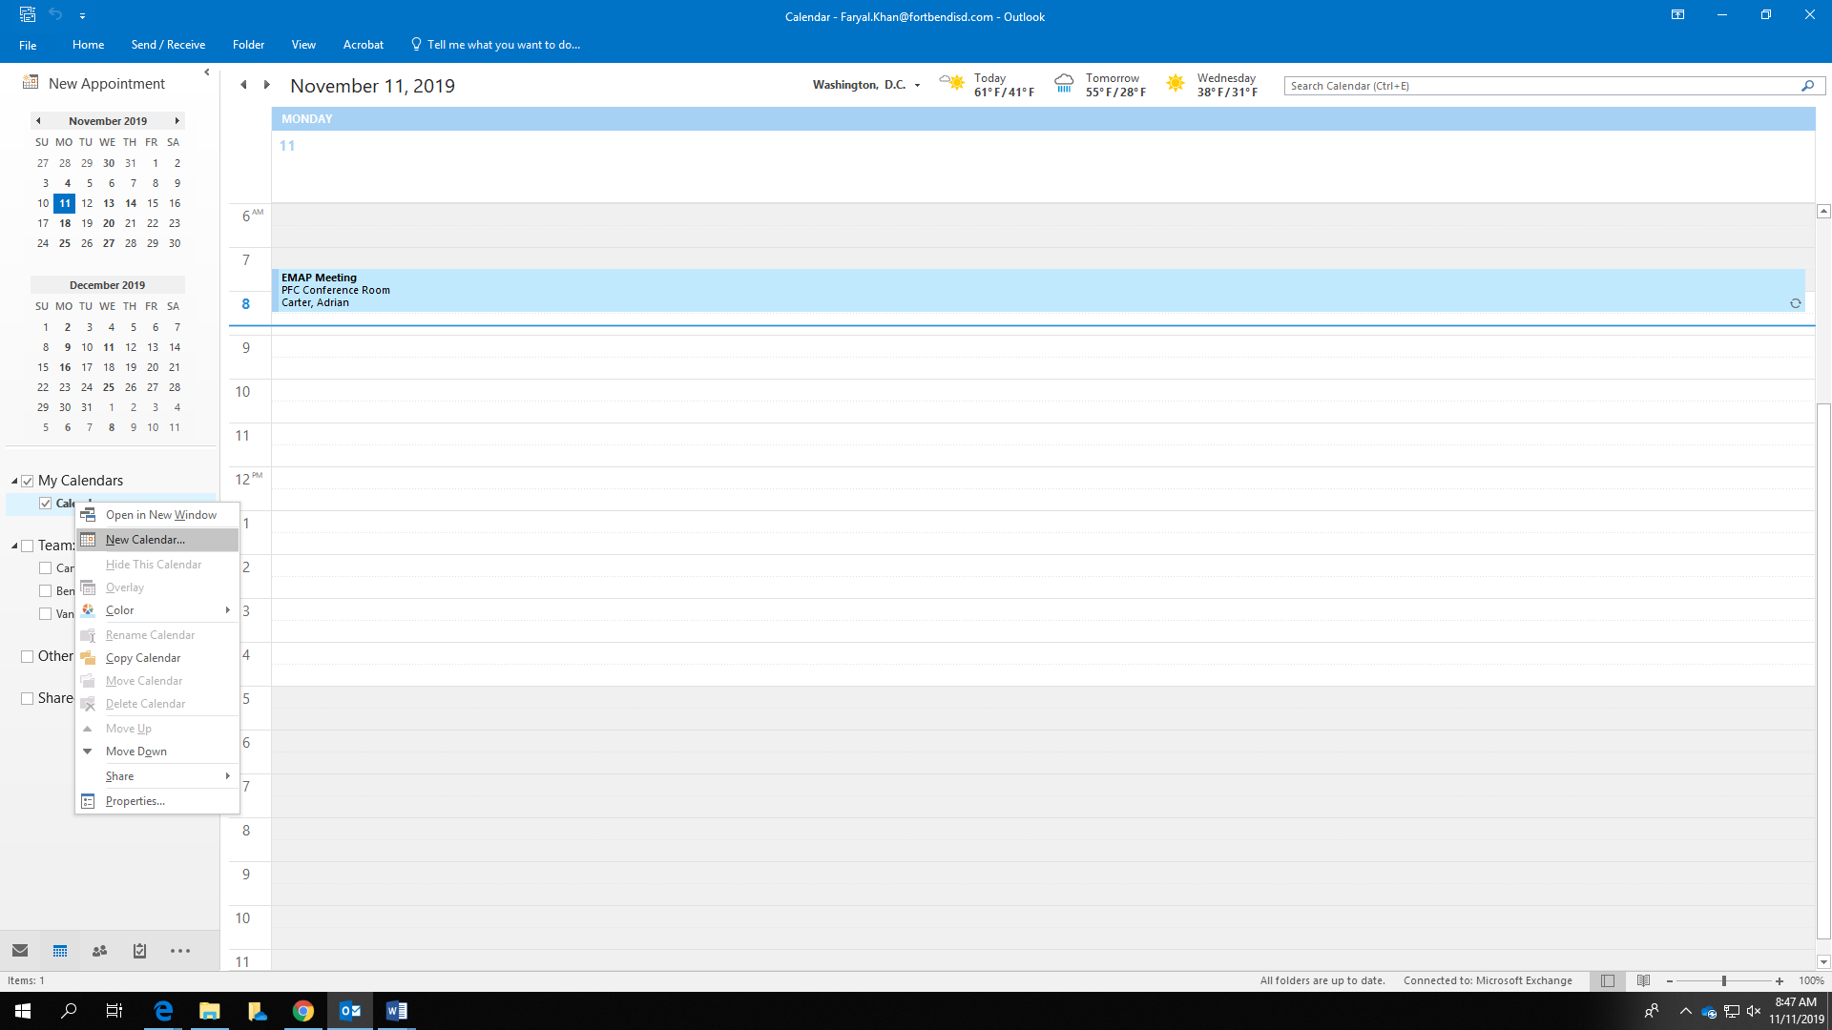

1. Write your **Calendar Name** and click **OK.**

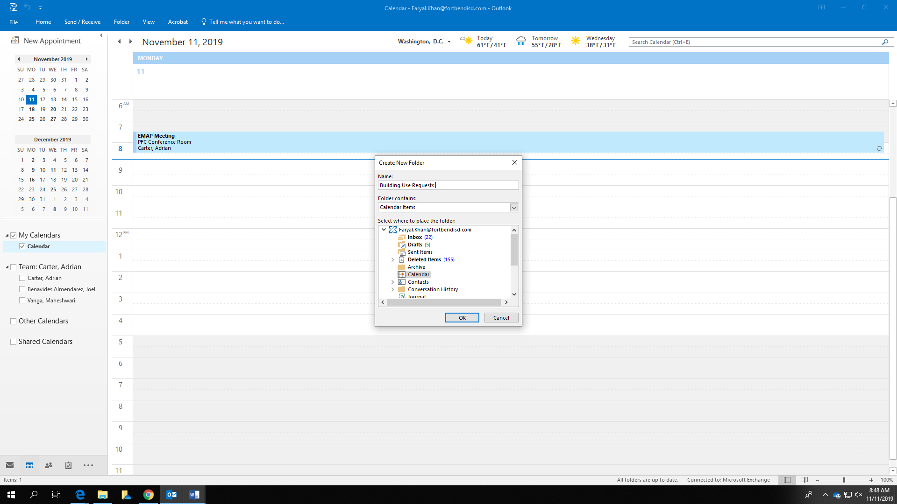

1. You will see your **newly created Calendar** in the left pane.
2. Right click on that calendar and go to **Properties.**

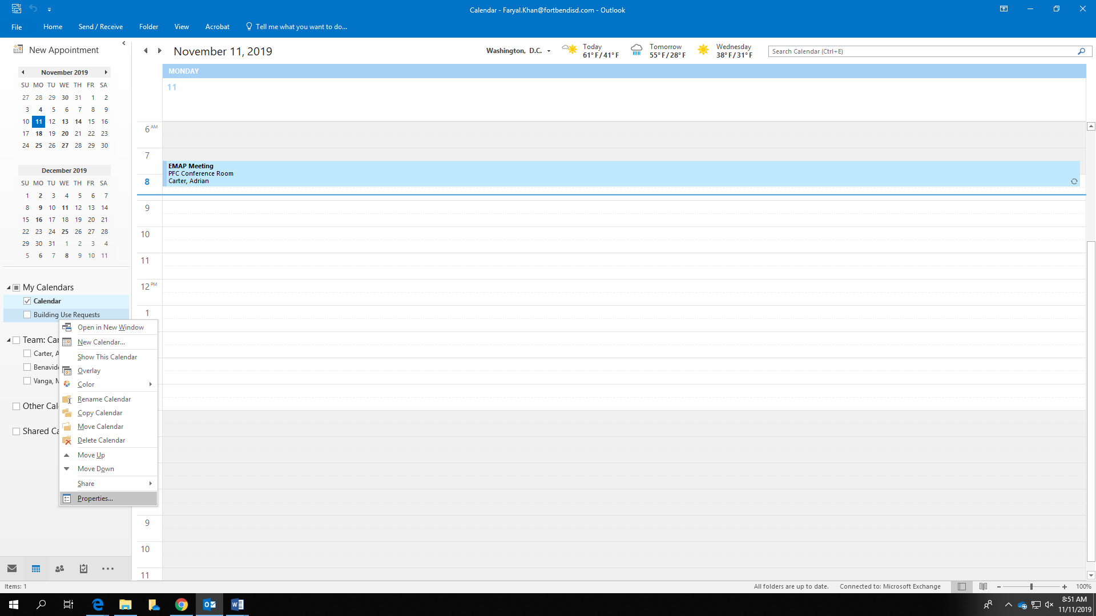

1. Go to **Permissions** Tab, Click **Add** to give access to others on this calendar.

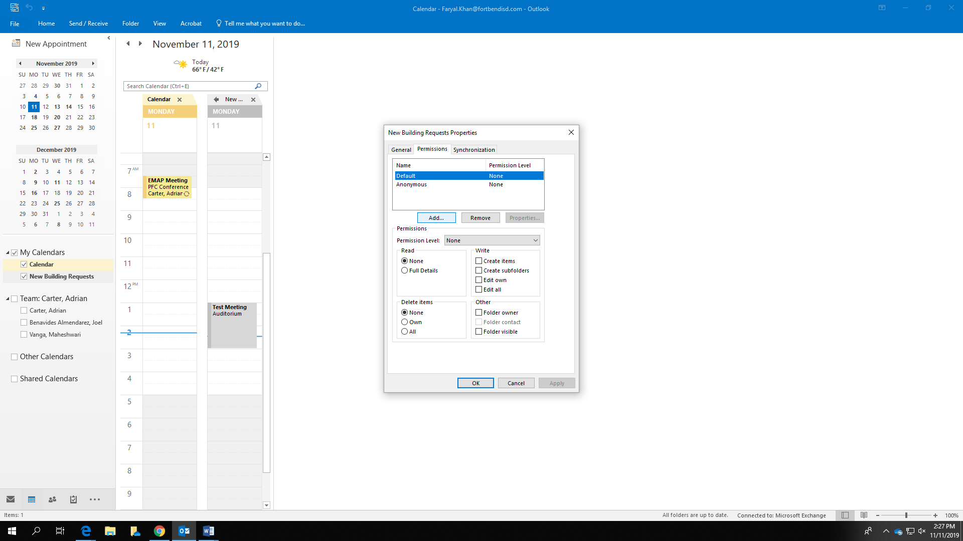

1. Search for the person you want to allow access to on this calendar, select that person’s name and click **OK.**

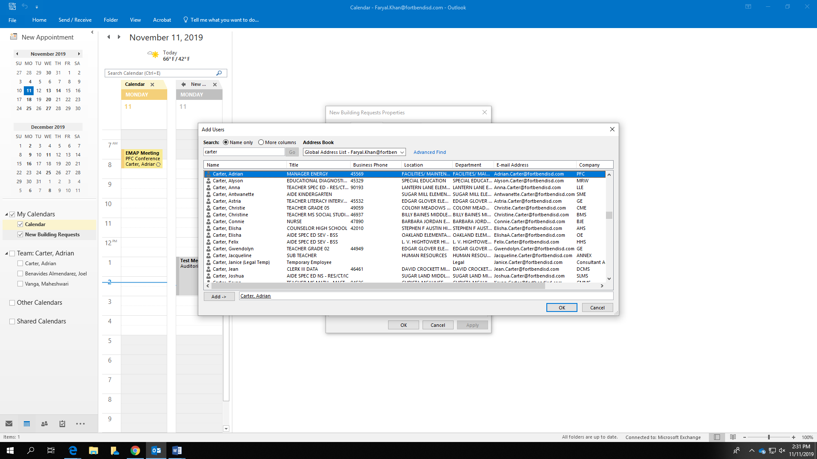

1. Now you have to assign **Read-Only** permissions to the person you have added. Under Read, select **Full Details.** Do not check or select anything else. Click Apply and you may add another person by repeating steps 5 to 7. Click **OK** to complete.

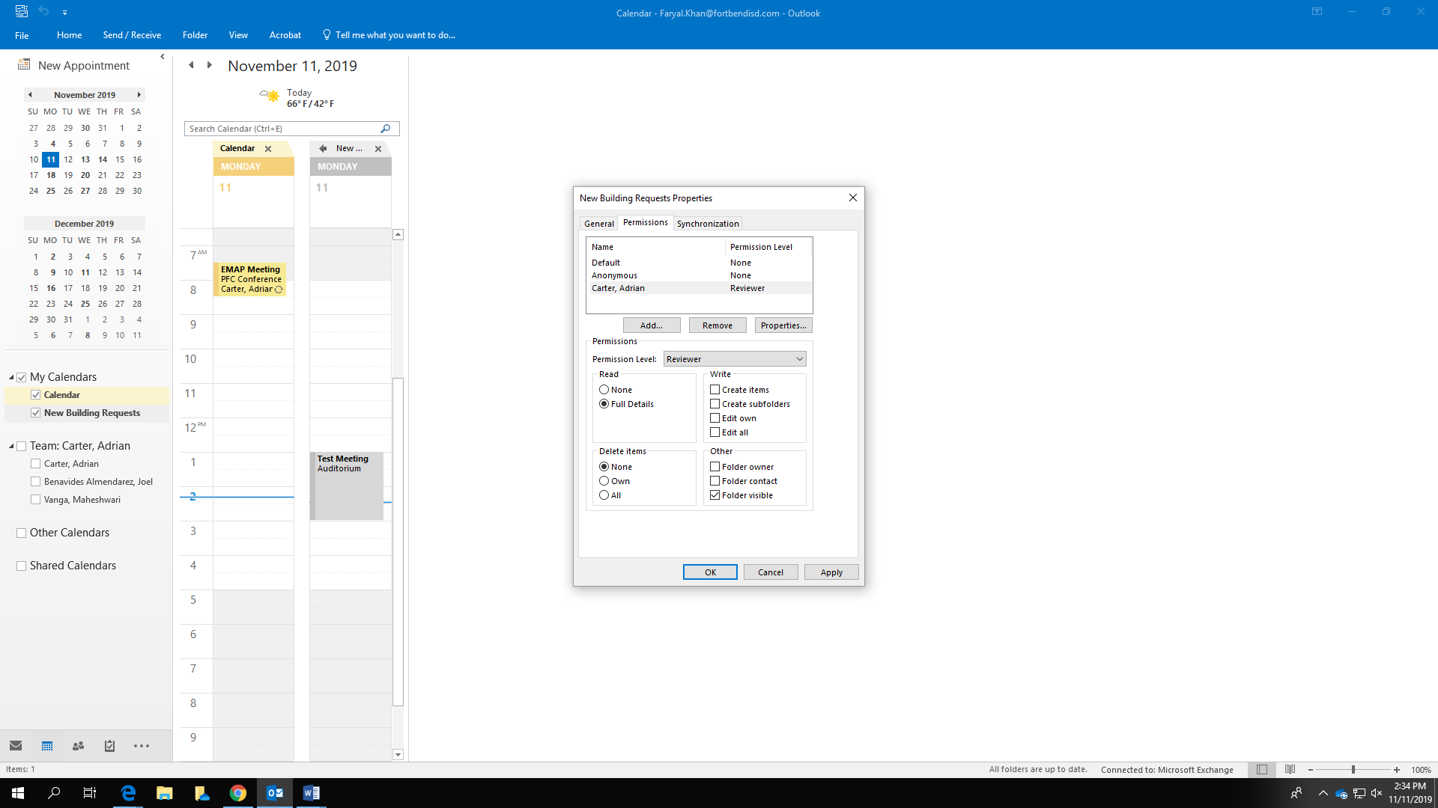

1. Now you want to share your calendar with the person you have added. You can right click on the calendar, go to **Share** and select **Share Calendar.**

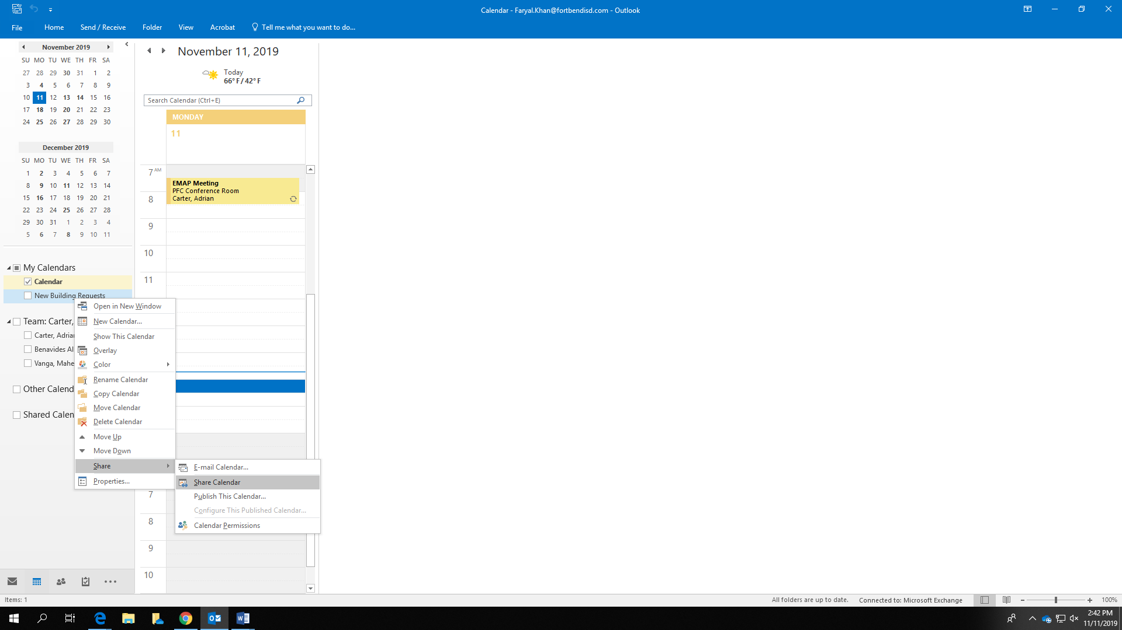

1. Type the email of the person you previously gave permission to access your calendar and click Send

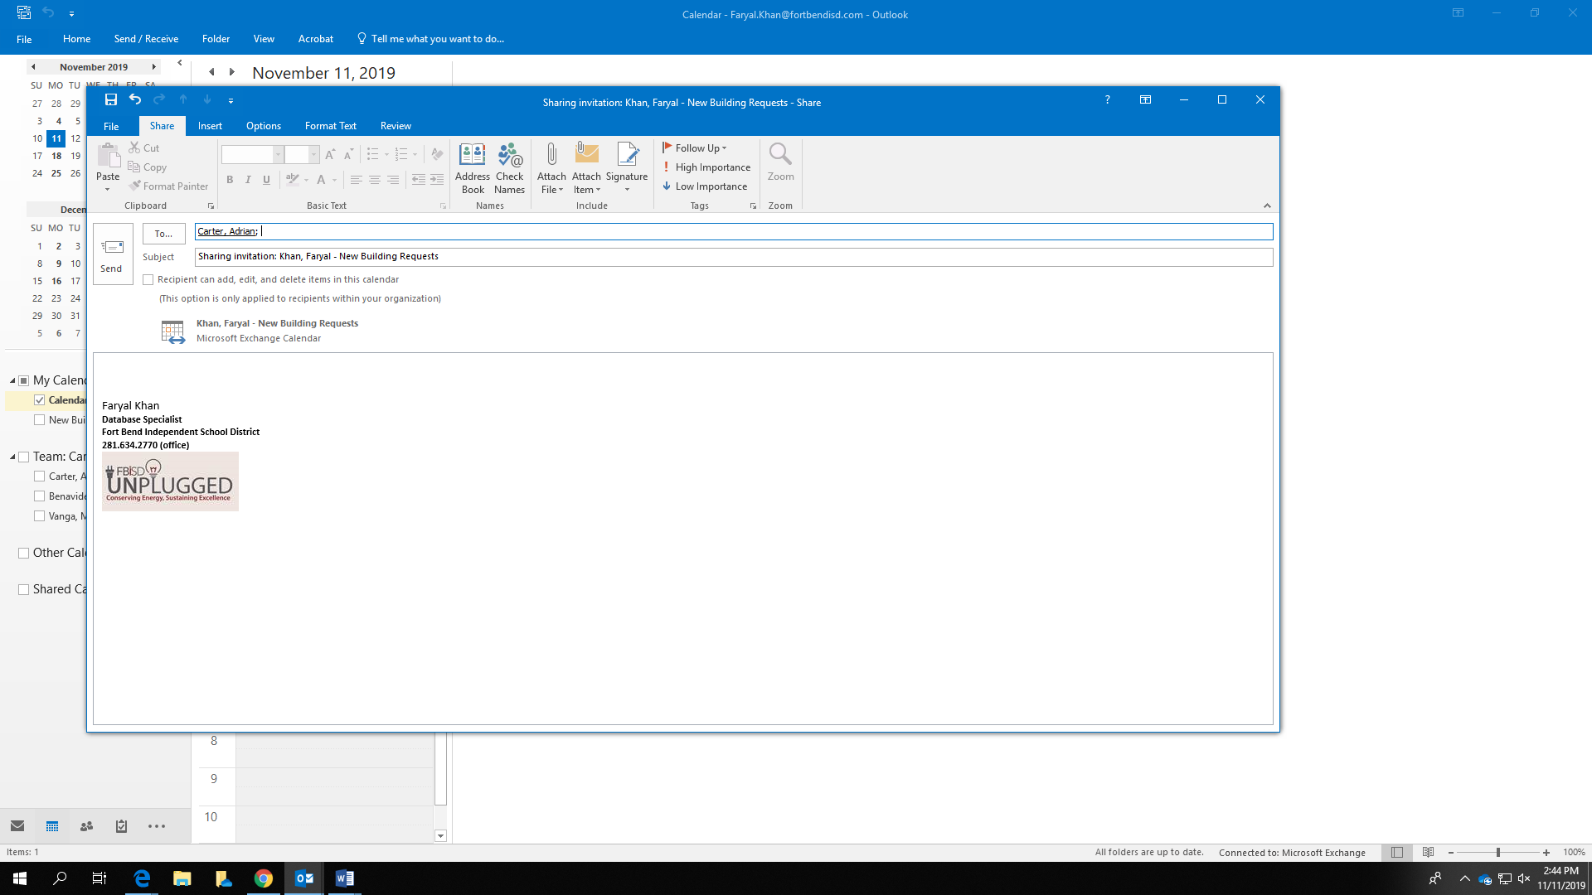

1. The email-receiver will open the mail and click on the top left tab of the email to add this calendar to the **Calendar Tab.**