[](http://www.google.com/url?sa=i&rct=j&q=&esrc=s&source=images&cd=&cad=rja&uact=8&ved=0ahUKEwjRlPvFsIfUAhVBeCYKHYyzAqcQjRwIBw&url=http://techmarketingbuffalo.com/guide-instagram-logo/&psig=AFQjCNFBpP2AkjgE1eprEEsKXajUI-rdrQ&ust=1495675485827712)

**staff**

**Personal Photo**



**TEACHER**

[](https://en.wikipedia.org/wiki/Instagram)

***Mrs. Booker***



**Personal**

**Birthday:** November 9th

**Hometown:** San Antonio, TX

**Family:**

**A few of your favorites:** Coffee and Bath/Body Works

**Favorite Hobbies:** Shopping, Traveling and spending time with family

**Favorite Artist/Music Genre:** Old School R&B (Motown/ 90’s)

**Favorite High School Memory:** Track Meets/ Football Games/ Powder Puff Football

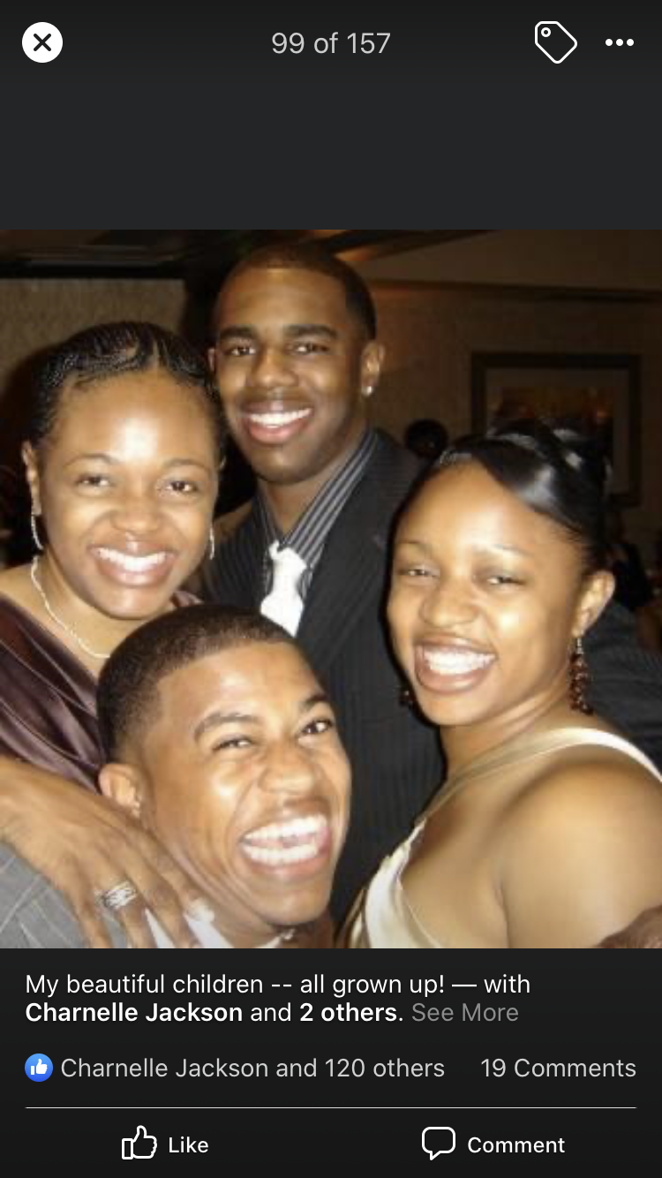

Teaching Assignment or Role on Campus

# years of teaching: 10

Marshall/FBISD: Year# 7

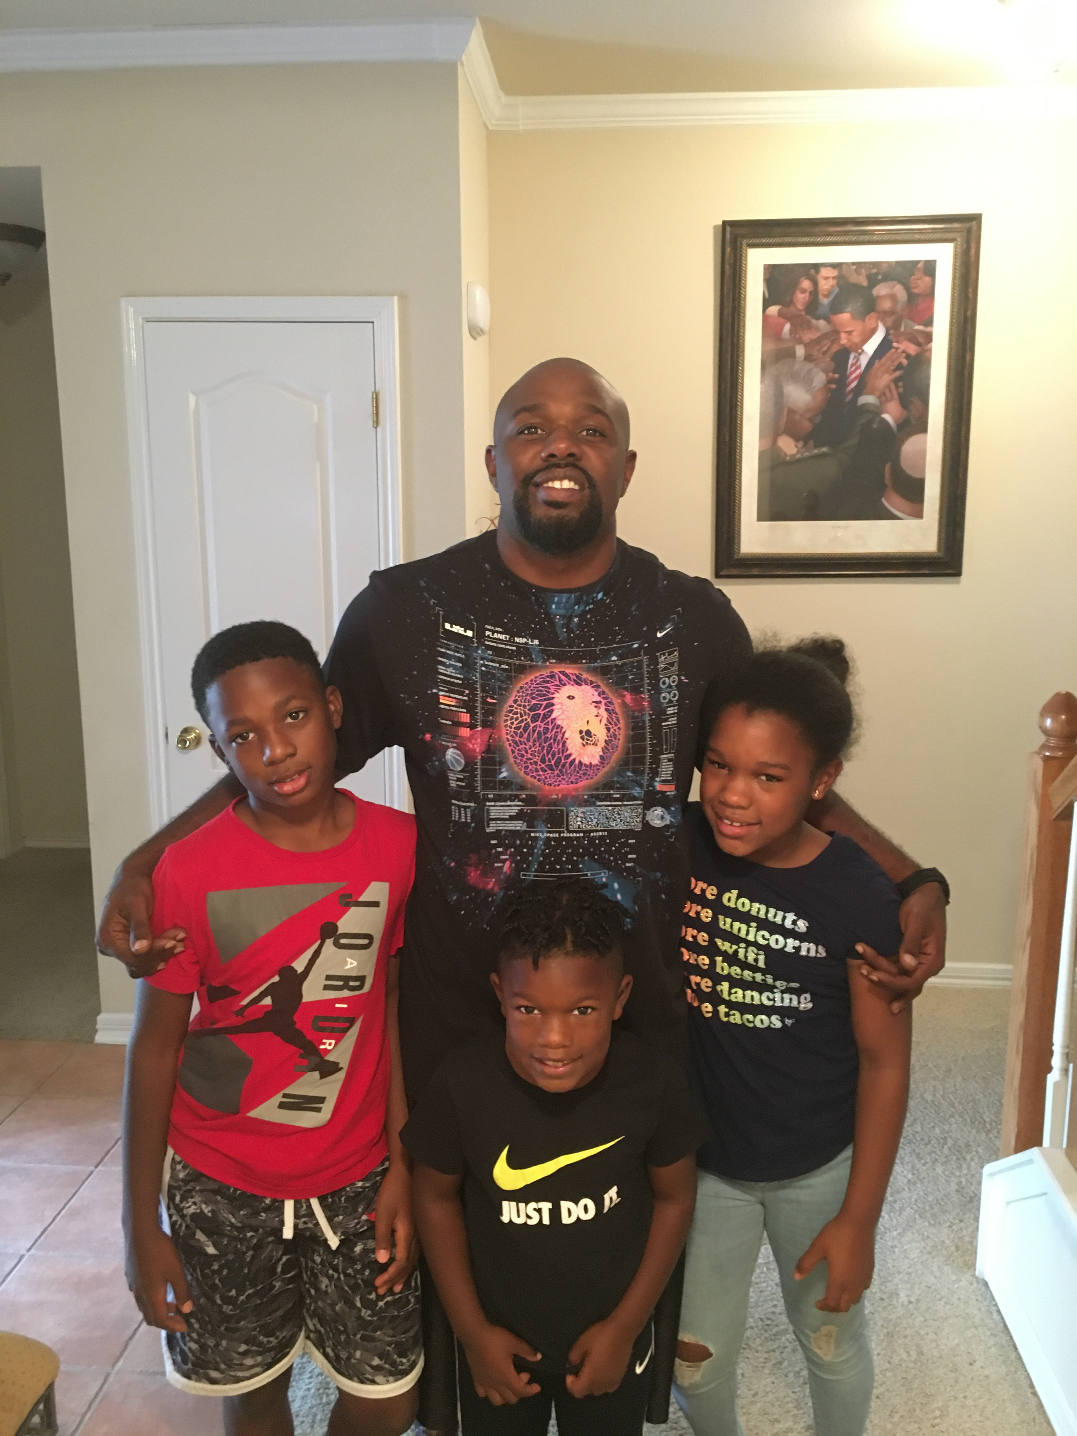





Motivational quote/Motto:

Education is our passport to the future, for tomorrow belongs to the people who prepare for it today.

~Malcom X

**TEACHER**