[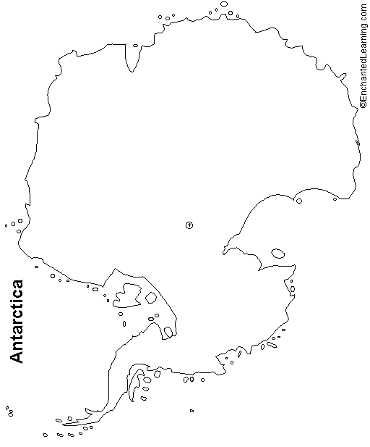](http://www.enchantedlearning.com/geography/continents/)[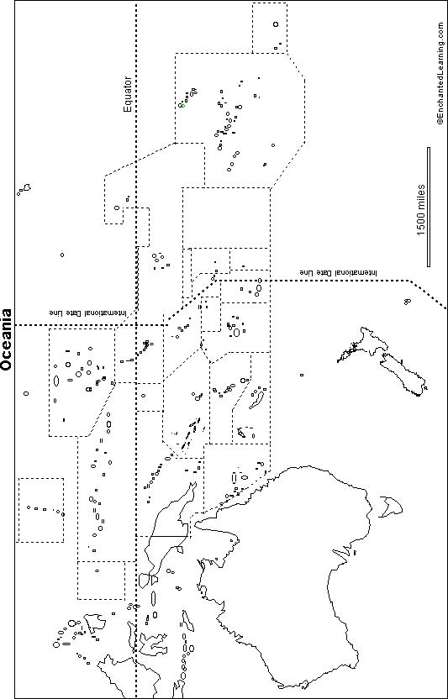](http://www.enchantedlearning.com/geography/australia/)