***Who***? Only students who have purchased a WHS paintable parking permit for the 2025-2026 school year. Fee is $25, paid to WHS Class of 2026.

***When***? TBD from 10:00 a.m. – 3:00 p.m. to display our Willowridge High School Spirit by painting your personal cement canvas!

Guidelines for your sketch:

Think of your parking spot as a T-shirt that you want to wear to school. Your spot must be in dress code - so no references to drugs, alcohol, smoking, gangs, etc. Keep it classy! Examples…You can use your name, your jersey number, instrument you play, or favorite hobbies. Your spot should be fun and reflect who you are.

Paint Requirements:

* Paint must be latex "liquid" paint, no aerosol cans, etc.
* Must include Willowridge High School colors in any combination.
  + Paint can be purchased at Home Depot (? location)
* Students will receive a 20% discount
  + Must mention “Willowridge High School” at checkout for discount and purchase at least the two school colors.
  + School colors – ?

What to bring on Paint Day?

* Proof of WHS 2025-2026 student-parking permit purchase
* Approved sketch before painting
* Latex paint and paint brushes or rollers
* Masking tape or painter's tape to tape off the lines around your spot and the parking space number before you start painting
* Broom to sweep off parking space and clean-up supplies
* Popup tent (to cover just in case of rain)
* Ground covering to place your paint on while working

What NOT to bring?

***X*** Air or airless paint sprayers

***X*** Unapproved paint

***X*** Unapproved sketch

***X*** Any item that violates FBISD Policy

No Refunds after you have painted your spot. If you paint something inappropriate on your spot, you will forfeit your 2025-2026 Willowridge High School parking privileges as well as be held financially responsible for the removal of the painted area.

Again, you will not receive a refund.

Also, you will be subject to disciplinary actions outlined in the Fort Bend ISD student code of conduct.

No touch-ups, repainting, etc. after ***TBD*** without campus administrative approval.

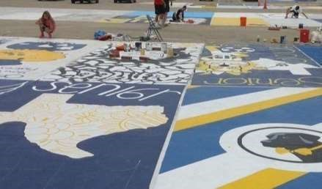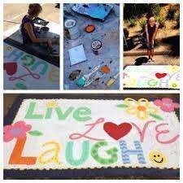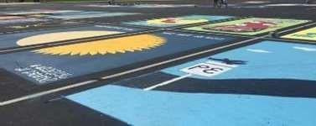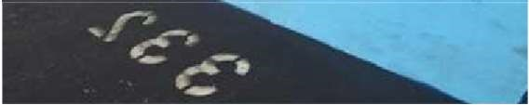

This design sheet must be done in color and must represent exactly what will be painted on your parking space if accepted. The deadline for submitting drawings will be ***TBD*** to Mr. Schultz.

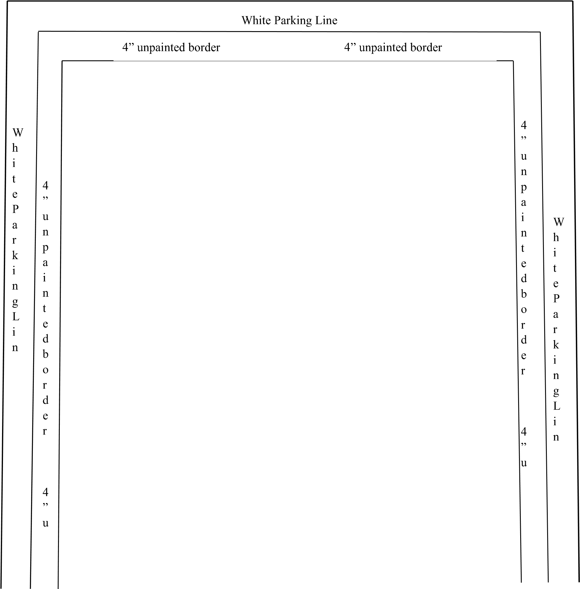

_______________________________ _________________________________ Student’s Printed Name Parent’s Signature

___________ _________________________________

Permit # WHS Admin’s Approval Signature

# Reserved Painted Parking Spaces Student Contract

Name: ______________________________________ ID Number: ____________________

License Plate Number: ______________ Phone Number: ______________

I hereby agree to abide by all of the following rules and regulations corresponding to my privilege of having a reserved painted parking spot:

Student’s initials & Parent’s signature required

______ I fully understand that my 2025-2026 Willowridge High School student-parking privileges can/will be forfeited if I violate any of the following expectations and/or violate campus/district policy ***without refund***.

_______I understand that me or my family will be held financially responsible for the removal of any unapproved designed and I will not receive a refund.

______Upon purchasing my parking spot, I will only use WHS approved water-based exterior latex paint.

______I am fully aware that I am not allowed to use spray paint, reflective paint, or fluorescent paint of any kind.

______I will only paint within the marked parking space that is drawn for me.

______I understand I must bring my own brushes and painting supplies to decorate my spot.

______ I will only paint my approved design following all the guidelines in my parking space. ______I understand that my painted design must be completed by ***TBD*** or as directed by campus administration.

______I fully understand that I can only paint in the parking area that I have been assigned to

# Student, Parent, and Administrative signatures required

________________________________ ____________________ Printed Name Student’s Date

__________________________________ ______________________

Guardian’s Phone # Guardian’s Signature

________________________________________

Willowridge High School’s Admin Approval Signature