Name: __________________________________________ Class Period: _____ Date: _____________

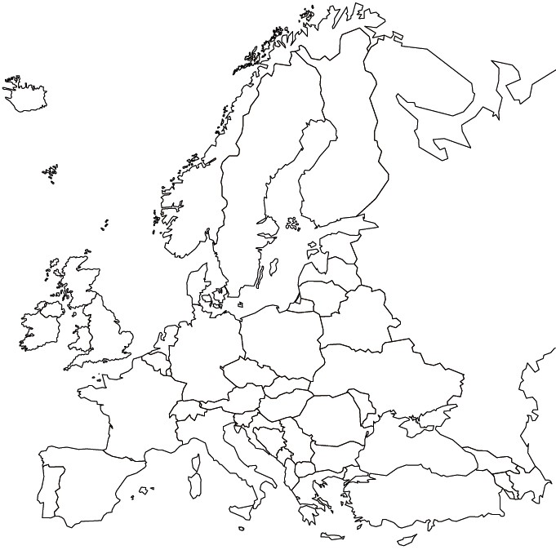_________________________________

**Directions:** Complete labeling listed. Use color pencils to color a thick border (neatly) inside the country. Do not use the same colors next to each other. Do not color the oceans. Draw physical features. Complete TODAL. Neatness counts.

**Labeling Map 1**

Countries

Albania

Austria

Belarus

Belgium

Bosnia and Herzegovina

Bulgaria

Croatia

Cyprus

Czech Republic

Denmark

Estonia

Finland

France

Germany

Greece

Hungary

Iceland

Ireland

Italy

Latvia

Lithuania

Malta

Moldova

Montenegro

Netherlands

Norway

Poland

Portugal

North Macedonia

Romania

Russia

Serbia

Slovakia

Slovenia

Spain

Sweden

Switzerland

Turkey

Ukraine

United Kingdom

Cities

Berlin

Istanbul

London

Moscow

Paris

Rome

**Labeling Map 2**

Bodies of Water

Adriatic Sea

Aegean Sea

Arctic Ocean

Atlantic Ocean

Baltic Sea

Black Sea

Caspian Sea

English Channel

Mediterranean Sea

North Sea

Strait of Gibraltar

Inland Waterways

Danube River

Rhine River

Thames River

Volga River

Mountains Ranges

Alps

Apennines

Caucasus Mountains

Pyrenees

Ural Mountains

Miscellaneous

Prime Meridian