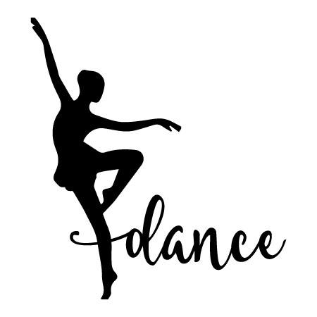
Ronald Thornton Middle School

Dance Course Syllabus

Instructor: Ms. Williams Avery.Williams@fortbendisd.gov

Location: RTMS
Quick Contact: Remind 101

Requirements

Students will provide a plain black shirt, black leggings or bottoms, and tan jazz shoes. Shirts may be short sleeve or long sleeved. Students may not wear crop tops, backless, see through or low front cut shirts. *You may purchase these items at a local store (Wal-Mart, Academy, Target, etc.) or online-- Amazon. Shoes will be worn at all dance performances.

Purpose of Course
Dance education strives to develop the student as a dance participant and an educated audience member. The course introduces the student to various forms of dance technique, dance health and wellness, and the creative process.

Summary of Course Content
Through daily participation in physical activities, the student will learn various dance forms such as ballet, jazz, modern, world dance, hip-hop, and musical theatre. Introduce students to various cultures, safety, health, and wellness. Exploring the creative process, students will develop their own creative skills and build confidence as performers.

Grading Procedures
Grades are determined by the following formula:
50% Daily participation and Dress Grades (Minor/ Daily Grades)
50% Performance Skills Tests and Written Tests/Assignments (Major Grades)
If a student is absent, they are expected to make up their test upon return to campus.

Expected Outcomes
Students will develop and refine motor skills, coordination, and kinesthetic awareness. They will develop self-confidence through performances. Students will enhance their understanding of the aesthetics of dance presentations.

Suggestions for Parents
The student will be successful in this course if she or he will stretch daily and practice dance combinations at home. The student should maintain all grades in other courses if they plan on performing. After school practice times will be based upon performances. Please download the Remind school communication app to keep up with any, and all practice, and performance information.

Dance Class Rules and Procedures

Dance Attire
Daily class attire for all students is "all black”, movement clothing outlined on the first page. Hair should be off neck, remove gum (no gum, candy, or food will be prohibited in any dance area), NO jewelry is to be worn. Safety first!

Student Participation
Each student must dress out and participate every day. Parental notes will excuse a student from physical participation for ONE day. A physician’s note is required for any circumstance that the student needs to sit out of activities for more than one day. Those students that are not physically participating will be given written assignments.

The procedures for tardies:
- Students will be marked tardy if not in the room when the bell rings.

The procedures not dressing out or failure to participate:
- Students will be deducted participation points.
- Parent contact will be made if reoccurring problems occur.

Point Deductions
If a student does not dress for class and/or does not participate the students will receive a 0 for their daily dress out grade.

If a student does not dress out on a skills test day, point deductions will be taken off test grade.

Other point deductions for infractions are as follows:
- 1 to 20 points- Poor participation or unsatisfactory conduct in class or in dressing area.
- If students do not participate in the ENTIRE class period, the student will get points deducted from daily participation grade.
- THERE IS NO SITTING OUT—unless you are injured or have a doctor’s note, you will receive zeros. (If a student makes a habit out of not actively participating in class, they may be asked to get a schedule change)

Roll Check
Upon dismissal from morning checkpoints, students should dress out for class (or I suggest arriving to school in dance clothes). Students should be in the classroom, dressed, and in their roll call spot when the tardy bell sounds. Students will return to the P.E. locker rooms the last 5 minutes of class to change and use the restroom. Failure to follow these rules will result in disciplinary action.

General Rules-

Please DO NOT:

  - Touch any equipment without permission.
  - Eat, drink, or bring food or drink into the locker room or dance space.
  - Leave belongings overnight unlocked in the locker room.
  - Horseplay in the dance space or locker room
  - Leave the room without the teacher’s consent.

Cell Phone Policy
There will be absolutely No cell phones or smart devices (iPad, watches, tablets, air pods, etc.) used during dance class OR practice. There will be times, such as during choreography, that you will be permitted to use your device, in this case, you are expected to use it for class purposes ONLY.

After School Practice and Activities
Students that are in this class will be given opportunities to participate in RTMS and Almeda Crawford High School performances. To better these performances there will be SOME practices called after school. In the event that you cannot attend practice, you may not be in the performance. It is at the director’s discretion. If you are not passing your classes, you will not perform. This class/opportunity is a privilege, that will be upheld with the up most respect and responsibility. You are not only an ambassador for RTMS, but for FBISD and you are expected to carry yourself with pride and resilience.

Costume Checkout and Returns
When you borrow/check out a costume, you will sign the item(s) out from Ms. Williams. From the time that you checkout the costume, it is your responsibility to handle it with care. If you damage or lose an item, you will be expected to replace the item. After using a costume, students are then expected to immediately check them back in with Ms. Williams. Please DO NOT wash the costumes. These items are delicate and require specific cleaning procedures. All items will be clean prior to hand out.

Ronald Thornton Middle School Student Agreement & Parent Consent Form

- I have read the dance class syllabus and requirements for the Ronald Thornton Middle School Dance Class. I understand there is a financial requirement for purchasing class wear for my daughter/son to participate fully. This will help my daughter/son achieve a full dance experience.
- I understand that there are clothing requirements for all dance students, and failure to wear proper attire will result in academic penalties/and or removal from a performance.
- I understand that there are participation requirements for all dance students, and failure to participate will result in academic penalties/and or removal from a performance.
- I understand that there are performance requirements for all students enrolled in dance, as stated in the dance TEKS.

Please sign and return. Due on/before Friday August 16,2024. (This signed and returned paper will be for a grade.)

Student Name: Grade: Student ID#:

Parent Name: Parent Email:

Parent Phone Number:

Parent Signature: Date:

Student Signature: Date:

