**Note: There can be several ways to approach these kinds of problems. The answers you see below are not “absolute” answers, just one kind of process of thinking.”**

**Sample Free-Response Questions**

Experimental Design

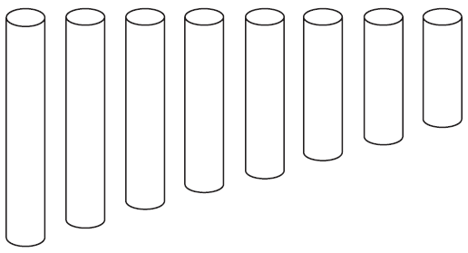

1. You are given a set of chimes that consists of eight hollow metal tubes open at both ends, as shown above. The chimes are played by striking them with a small hammer to produce musical sounds. Your task is to use the chimes to determine the speed of sound in air at room temperature. You have available a set of tuning forks and other common laboratory equipment but are not allowed to use electronic equipment, such as a sound sensor. (A tuning fork vibrates when struck and produces sound at a particular frequency, which is printed on the tuning fork.)
2. Describe your experimental procedure in enough detail so that another student could perform your experiment. Include what measurements you will take and how you will take them.

The chimes, when struck, will generate the first harmonic frequency. This means the length of the pipe is ½ the wavelength of sound it generates. Use a meter stick to measure the length of each pipe and multiply by 2 to record wavelength of sound for each pipe. Strike one of the chimes and listen to the tune that is played. Attempt to find a tuning fork of known frequency which matches this tune the best. Strike the chime and tuning fork at the same time and listen to the two tunes together. If you notice a beat is generated, the frequency of the beat will equal the difference in frequency of the chime/tuning fork. Use your skills of pitch to determine whether the chime is this many Hz above or below the tuning for frequency. **Example**: If the tuning fork has a frequency of 450 Hz and the frequency of the beat is 3 Hz and it sounds like the chime is at a slightly lower pitch than the tuning fork, then the frequency of the chime is 447 Hz. Do this for each chime.

1. Describe how you will use your measurements to determine the speed of sound, in enough detail that another student could duplicate your process.

Plot a graph in the form of and perform a power regression on the data. Students should observe that there is an inverse relationship between the variables: . Linearize the graph by taking the inverse of every frequency data value but leaving the wavelength value untouched. Regraph and you should observe that it is a linear relationship. The slope will correspond to the velocity of sound since .

1. Describe one assumption you made about the design of your experiment, and explain how it might affect the value obtained for the speed of sound.

I made the assumption that the tuning forks might not match perfectly with the frequency values written on their sides. It is common that over extended usage, the tune of a tuning fork begins to change slightly. Since this frequency was critical in determining the chime frequency, any variation here would have affected evaluating the frequency of the chime.

Another example: I made the assumption that the student would be able to determine the small frequency of the beat accurately without use of a high tech device to do so. This could affect our data since the beat frequency could have actually been an abstract number like 2.78 Hz while the student recorded it as 3Hz. This small difference could lead to a large percent error if made consistent.

Keep in mind, the question only asked for **one** example. If you guys can think of another great! But no need to write everything I did in its entirety.

1. A student doing a different experiment to determine the speed of sound in air obtained wavelength and period measurements and created the following plot of the data. Use the graph to calculate the speed of sound and include an explanation of your method.

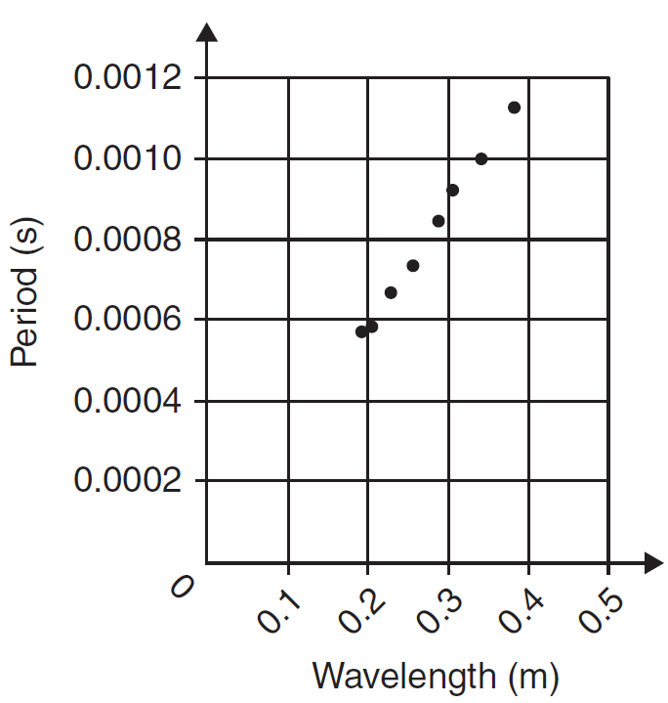

Notice the units: seconds over meters. It seems like finding the velocity would be as simple as inverting this number.

Which is pretty close to 343 (the actual speed of sound) so you know you probably did it right!

Be sure to show work.

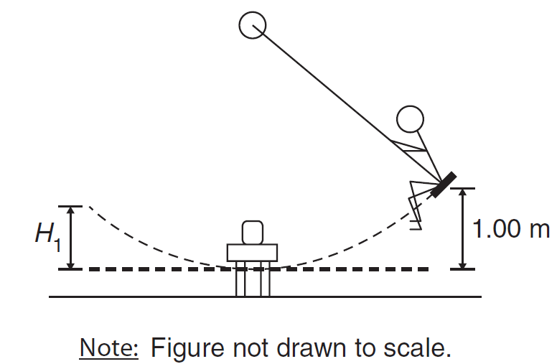

1. A student of mass 50.0 kg swings on a playground swing, which is very light compared to the student. A friend releases the seat of the swing from rest at a height of 1.00 m above the lowest point of the motion. The student swings down and, at the lowest point of the motion, grabs a jug of water of mass 4.00 kg. The jug is initially at rest on a small table right next to the swing, so it does not move vertically as the student grabs it. The student keeps swinging forward while holding the jug, and the seat reaches a maximum height *H*1 above the lowest point. Air resistance and friction are negligible.
2. Indicate whether is greater than, less than, or equal to .

_____ Greater than .

X

_____ Less than .

_____ Equal to .

Justify your answer qualitatively, with no equations or calculations.

The student’s mechanical energy is conserved from the beginning to the bottom of his swing. His energy is converting from gravitational potential energy to translational kinetic energy. However, as the student grabs the box, a perfectly inelastic collision takes place and some of his kinetic energy is lost to heat. His mechanical energy is now less than it was before, so as it begins to convert back to gravitational potential energy, the high he obtains must be less than his original height.

1. Explain how can be calculated. You need not actually do the calculation, but provide complete instructions so that another student could use them to calculate .

Use the conservation of energy between the initial point and bottom of the student’s swing to calculate his maximum velocity: . Use this velocity and apply the conservation of momentum during the inelastic collision (when he grabs the jug) to determine the velocity of the student after the collision: . Use this velocity in the conservation of energy of the student/jug object as it obtains its new maximum gravitational potential energy at height : . Since is smaller than , should be smaller than .

1. The student now swings backward toward the starting point. At the lowest point of the motion, the student drops the water jug. Indicate whether the new maximum height that the seat reaches is greater than, less than, or equal to .

_____ Greater than .

_____ Less than .

X

_____ Equal to .

Justify your answer qualitatively, with no equations or calculations.

“Dropping” the jug is not the same as “throwing” the jug. By dropping the jug, both the jug and student maintain the velocity they obtained at the bottom of the swing. The jug will follow a parabolic path down to the ground, but the student will continue moving up the arc. However, since his velocity and hence his kinetic energy, high obtained gravitational potential energy does not change either. Thus, he will return to the same height as .