**School Dude-FS Direct Step by Step Guide for Requesting Normal Schedule**

1. Use the following URL to access School Dude:

<https://login.schooldude.com/mlogin?productid=community>

1. Enter Login Name and Password. Select FSDirect from the Go To Dropdown Menu:

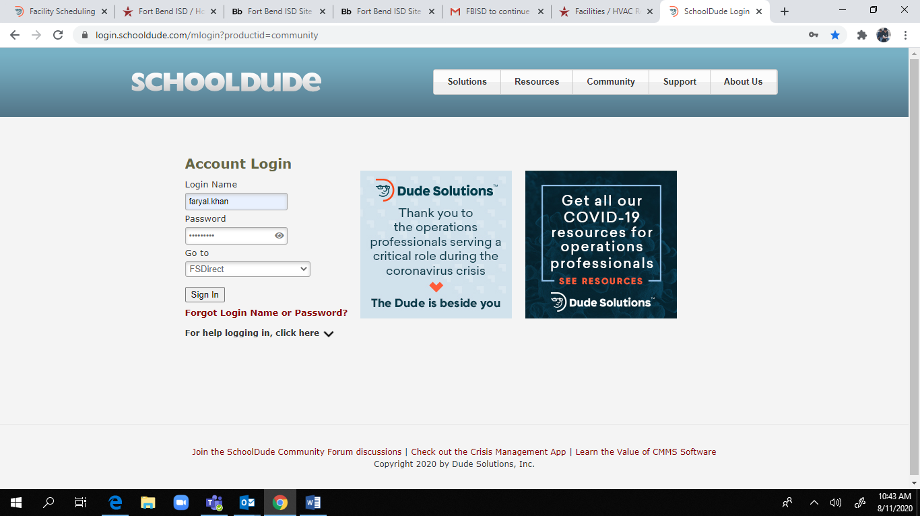

1. You will be directed to the Home Screen. Click on the New Schedule tab and you will be directed to the following screen:

Click on Normal Schedule.

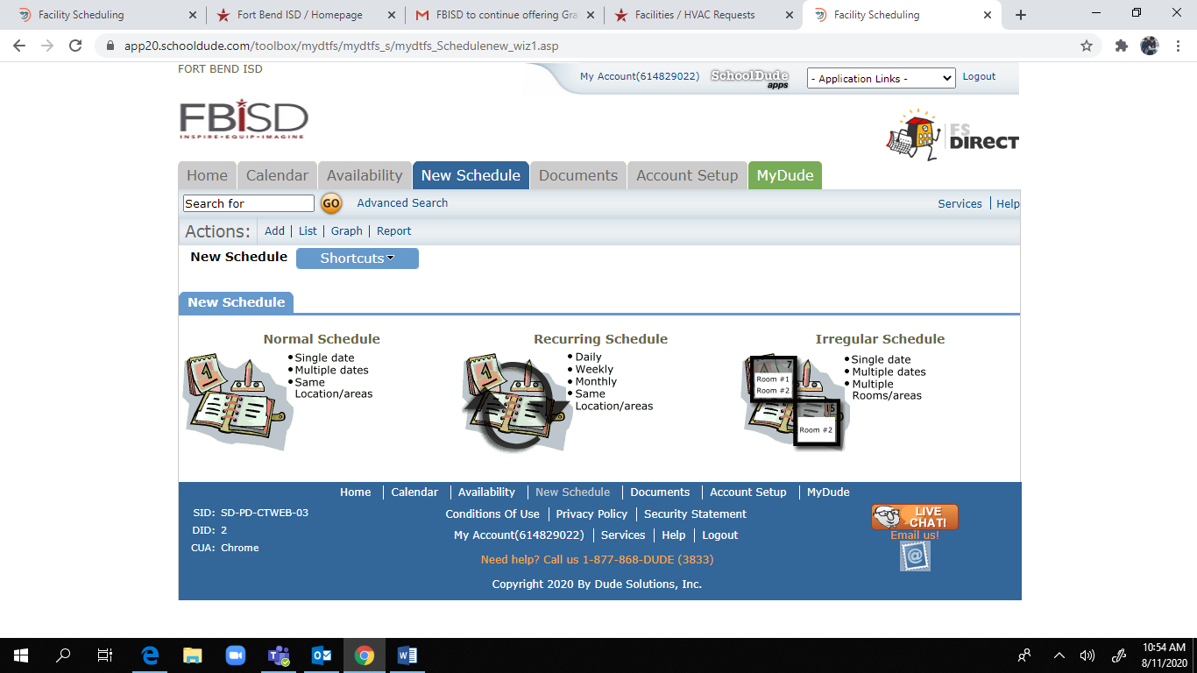

1. If Normal Schedule is clicked, you will be directed to the following screen:

* Enter Event Title followed by the campus code.
* Enter Event Description.
* Select Location from the drop down menu.
* Click on the binocular icon next to Rooms. Click on the rooms needed and press OK. (You may select multiple rooms)
* Kindly do not select anything from Area or Building.

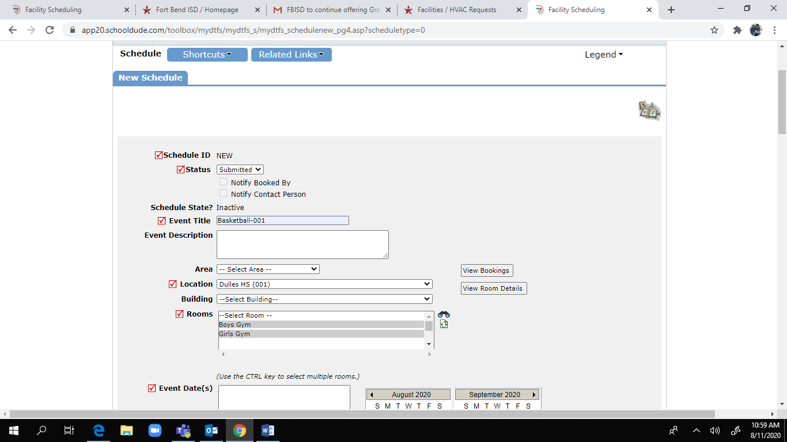

Scroll down

* You may select up to 20 dates from the calendar.(Please make sure that you select days only from the current month)
* Select Start and End times. Please be accurate.
* Please do not select anything for Setup Begin or Breakdown End Time.
* Please do not alter the Duration or Spans over boxes as they are auto populated.
* Under Additional Information, click on the radio buttons as per your requirements.

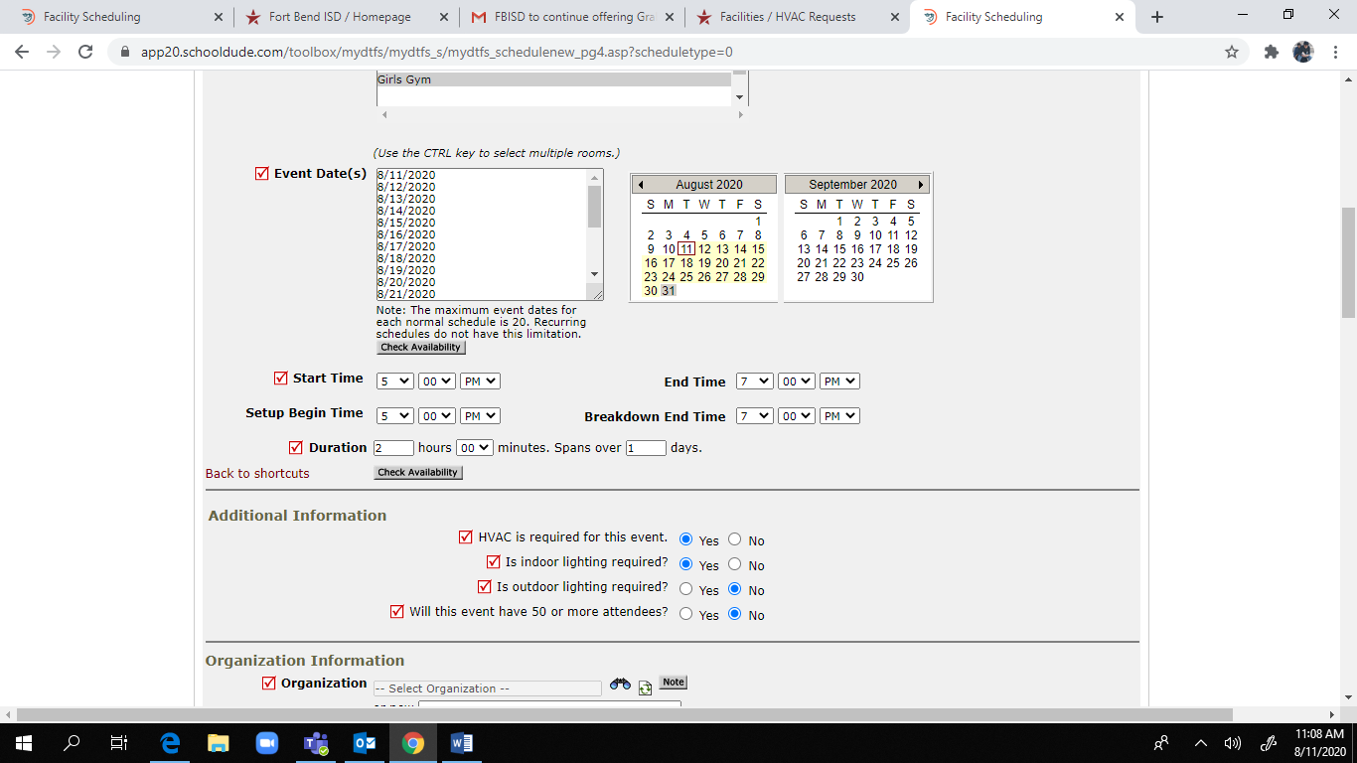

Scroll down

* Click on the binocular icon next to Organization and search for the school’s relevant department.
* Enter contact details for the Requester. This is the last data entry for this Request form.

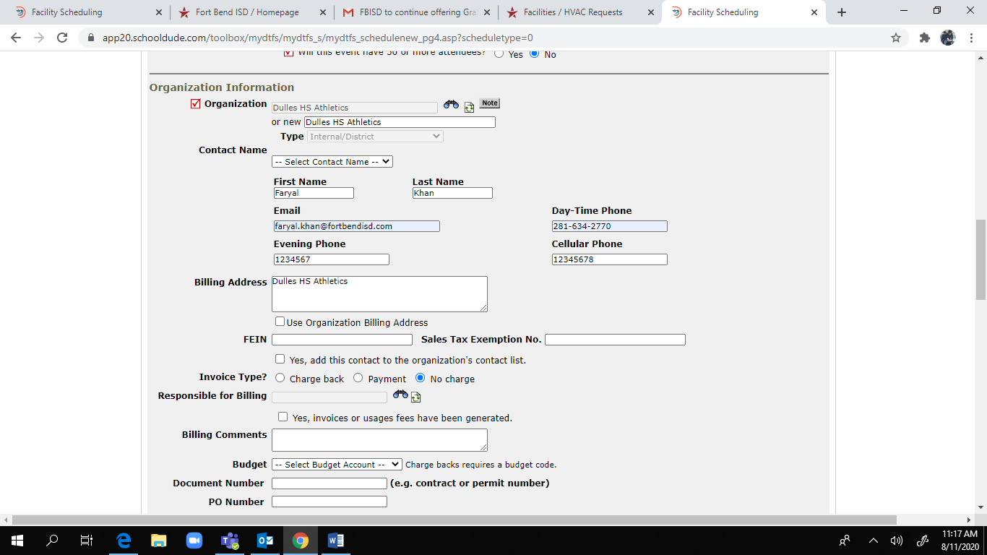

* Scroll down to the end of the form without entering anything else and click save. Your request will be submitted.

