**Online Athletic Medical Forms**

Please use the link below or QR Code to complete the required documents. The forms must be completed before an athlete can participate in Athletics class or Sports.

**Website:** <https://fortbendisd.rankonesport.com/New/NewAddAthlete.aspx>

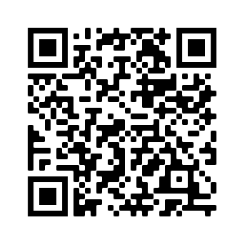

Please enter a zero “0” in front of the student ID number, which will make it 7 digits.

**Electronic Documents can be completed online using RankOne Sports Parent Account.**

*FBISD Athletic Participation Signature Page

*FBISD Emergency Contact Form

*Medical History

*UIL Forms Signature Page

**Health Tracking Forms**

Parents may email their child’s physical to the address below.

**SH-BHSathleticmedicalrecords** [**BHSathleticmedicalrecords@fortbendisd.com**](mailto:BHSathleticmedicalrecords@fortbendisd.com)

**If you experience problems with the forms, please contact Dr. Jasmine Dubose Bush High School Athletic Trainer to help you resolve the issue.**

Thanks for your continued support of DCMS Girls Athletics.

Coach Carter