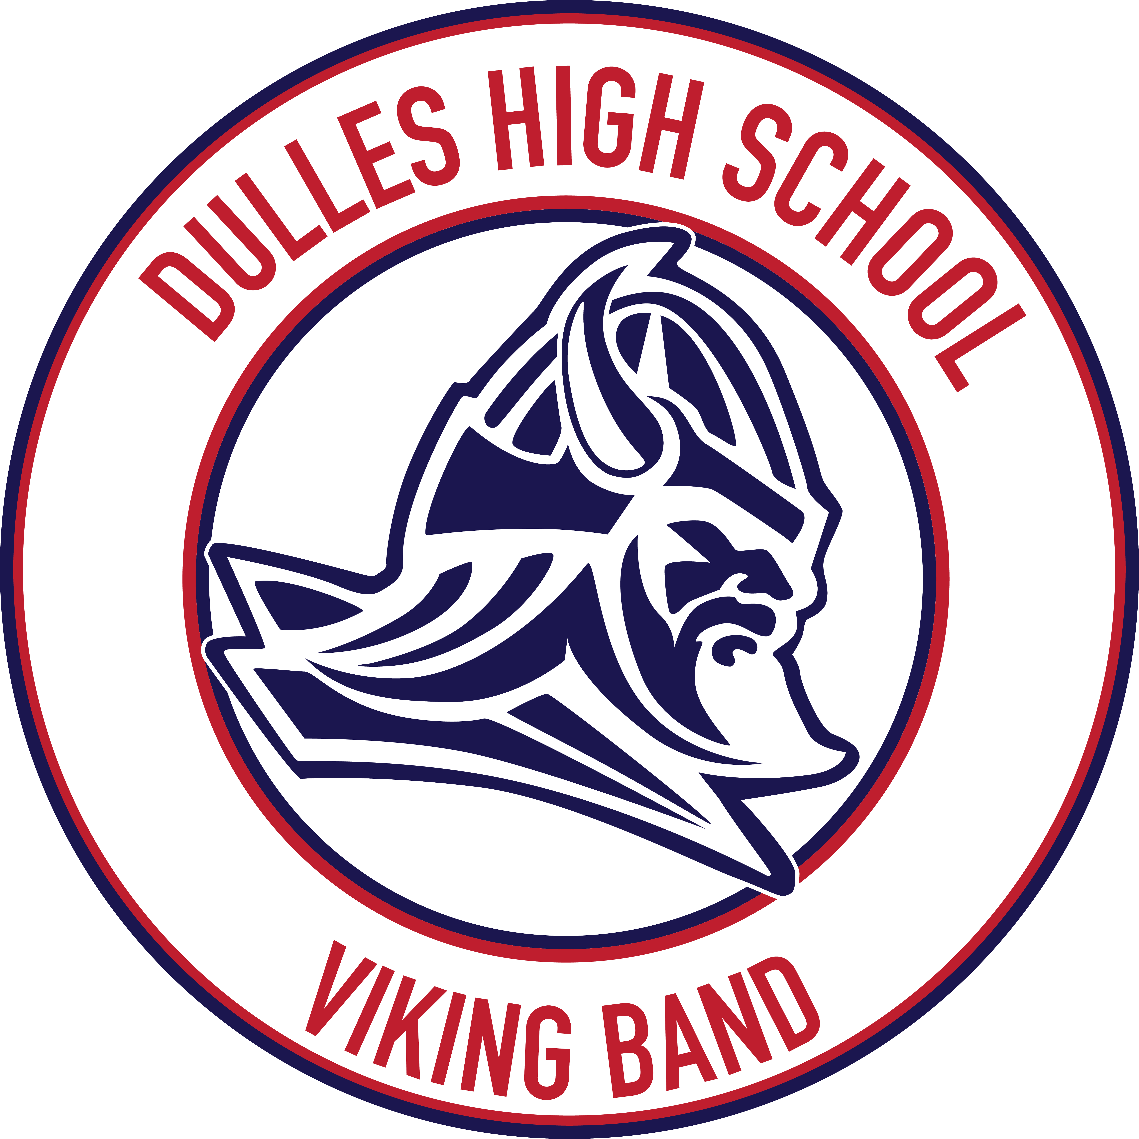
Dulles High School Bands
Course Syllabus for Advanced Band I-IV

Teachers: Joe Pruitt, Arnel Dayrit, and Spencer Clayton

Textbook: Smart Music and Essential Musicianship for Band Replacement Cost: $6.95

Purpose and Summary of Course Content:
Advanced Band I-IV is designed for the advanced wind and percussion student. Advanced instrumental technique, creative expression, and musical interpretation are taught as each relates to performance. Music is varied each year to expose students to different contemporary, modern, and classical wind literature. Students are involved extensively in performances and competitions throughout the year. Placement in this band is by audition only.

Grading Procedures:
Learning objectives are based on performance skills, responsibility, and participation. Therefore, students are expected to fulfill individual as well as group responsibilities. Term grades will be based on 100%:

50% Daily Grades (responsibility/before- or after-school rehearsals/other daily grades – see Band Handbook)

50% Major Grades (performance skills/inspections/playing and written tests)

Band is performance-based and a team activity, it is imperative that all members participate in every rehearsal and performance. Therefore, points will be deducted from the nine weeks grade as follows:

An unexcused absence from rehearsals that are extensions of classroom, i.e. sectionals = double daily grade
An unexcused absence from a performance which does not meet definition of extracurricular = double major grade

Expected Outcomes:
The student will gain a higher level of proficiency on their musical instrument and will gain the skills necessary to tackle and succeed in future performances through team and individual effort.

The learning triangle consists of the teacher, the student and the parent. Below are suggestions for how the parent can help their child to be successful in this course:

- Monitor the frequency of student practice at home and have the student demonstrate the music currently being performed in class.
- Note the upcoming events for concerts/contests and attend these events to aid in encouragement and help promote future success.
- Encourage the student to prepare and audition for the Texas Music Educators Association (TMEA) All-Region/All-State music events. Students generate greater acceleration in musicianship and proficiency on their instrument through preparation of this music.
- Encourage the student to prepare and perform a solo or participate in an ensemble at the University Interscholastic League (UIL) Solo and Ensemble Competition. Having an evaluation of the student’s performance by a specialist on the instrument enhances the student’s perspective in his musical development.
- Encourage the student to take private lessons from a qualified professional for their particular instrument. Private lessons are offered after school. They aid in tremendous learning for the student in specific areas of the instrument and provide additional help for preparation of UIL solos/ensembles and TMEA All-Region/All-State music.
- Please see DHS Band Handbook (located in Charms) for more specifics.

Tutorial Schedule:
Students can receive help with their music from a band director before and after school.

Conference Times:
Mr. Pruitt: 7:45-8:15 AM, M-F; Mr. Dayrit: 7 AM, M-F; Mr. Claytons 2:00-2:30 PM

