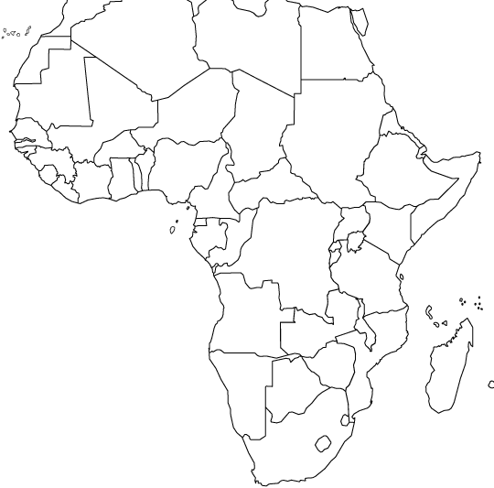

Map Quiz: Africa South of the Sahara

Labeling: Write the correct name of the numbered feature on the corresponding blank below.

- ________________________________ 6. ________________________________
- ________________________________ 7. ________________________________
- ________________________________ 8. ________________________________
- ________________________________ 9. ________________________________
- ________________________________ 10. ________________________________

Locating: Write the name of the correct feature or location that answers the following questions.
11. What body of water is directly east of Sudan and Eritrea? ________________________________________
12. Name the 3 countries that experience a Tropical Rain Forest climate: _______________________________________________________________________
13. What lowland feature is found in Tanzania? ___________________________________________________
14. What country is completely surrounded by South Africa? ________________________________________
15. What body of water lies between Tanzania and the Dem. Rep. of the Congo? _________________________
16. What country is bordered by Zimbabwe to the east and Namibia to the west? _________________________
17. Which countries have a Marine West Coast climate? ____________________________________________
18. What major city do we find in the Mediterranean climate region? __________________________________
19. What major city do we find in the Ethiopian Highlands? _________________________________________
20. What climate regions does the Niger River travel through? (of the climate regions labeled in your map) ______________________________________________________________________

21. _________________________
22. _________________________
23. _________________________
24. _________________________
25. _________________________
26. _________________________
27. _________________________
28. _________________________
29. _________________________
30. _________________________
31. _________________________
32. _________________________
33. _________________________
34. _________________________
35. _________________________
36. _________________________
37. _________________________
38. _________________________
39. _________________________
40. _________________________

