MedMyst- Medical Mysteries

You need to go to www.medmyst.rice.edu
Click “for students”; then “series 1/ original”; then “Mission 1: Orientation at O.R.B.”; then “PLAY”

What is a pathogen? _________________________________________________________________

ENEMY AGENTS:
- Helminths- Kingdom ___________________; examples- _____________________________
- Protozoans- Kingdom ___________________; examples- _____________________________
- Fungus- Kingdom ___________________; examples- _____________________________
- Bacerium- Kingdom ___________________; examples- _____________________________
- Virus- made of _____________________; examples- _____________________________
- Prion- made of ___________________; examples- _____________________________
List 4 diseases you are confident in what they do, and define them

List 4 diseases you are unfamiliar with. Look them up on the internet and briefly describe what they do:

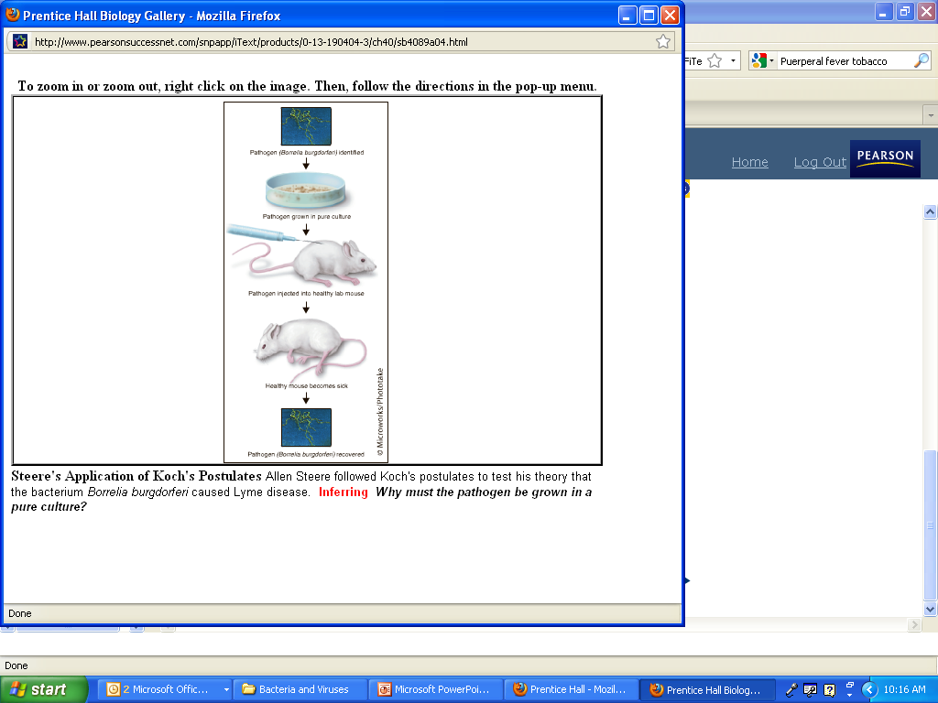

KOCH’S CONCEPTS
What’s wrong with the oranges?
What did Robert Koch do in 1890?

List Koch’s Postulates

GERM BLASTER
For each agent of disease, list the treatments and what each treatment does:
- Helminths-
- Protozoans-
- Fungus-
- Bacterium-
- Virus-
- Prion-
INFECT-O-RAMA
For each agent of disease, list modes of transmission:
- Helminths-
- Protozoans-
- Fungus-
- Bacerium-
- Virus-
- Prion-
Define the Types of Transmission:
- Direct Contact-
- Indirect Contact-
- Foodborne-
- Waterborne-
- Airborne-
- Animal Vectors-
BODY DEFENDER
What is the body’s first line of defense?
What is the body’s second line of defense?
What is the difference between the nonspecific and specific defense?
Non-specific-
Specific-
How do you develop immunity?

