**SWE DI Parent Information Night**

October 2, 2023

5:00 – 5:30

[Click here to join the Microsoft Teams Meeting](https://teams.microsoft.com/l/meetup-join/19%3ameeting_MjE4MzYxN2MtNWMyZC00YTgyLWE3ZTYtMTExNjMyOTEwMDAw%40thread.v2/0?context=%7b%22Tid%22%3a%22497d6241-391a-4277-91ac-bdd2a99f7054%22%2c%22Oid%22%3a%22436f035a-fdc8-406e-85bd-5b2fe312d344%22%7d)  
**Meeting ID:** 257 828 637 706 **Passcode**: LEGbLj

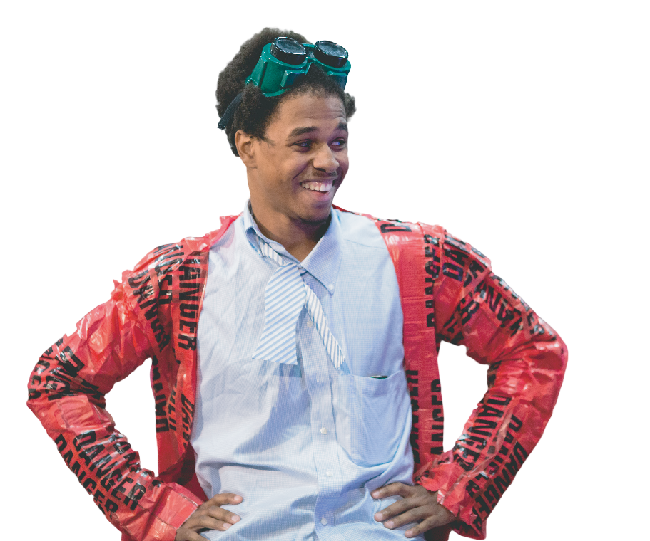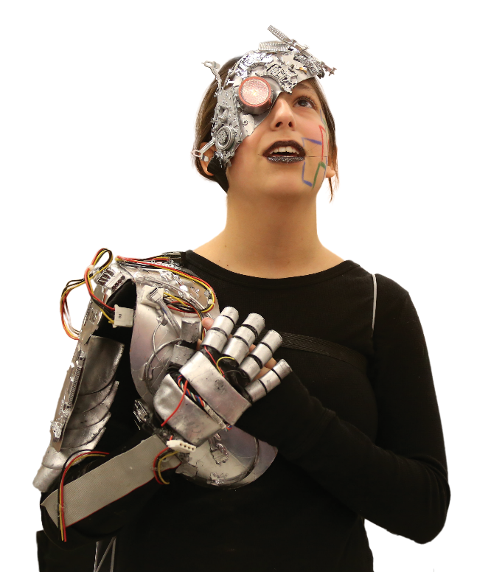

# **CHALLENGE**

**PROGRAM**

## Learning Objectives

**ABOUT THE PROGRAM**

Destination Imagination (DI) is a project-based educational program that inspires and equips students to become the next generation of innovators and leaders. Teams in our program improve in creative thinking, critical thinking and collaborative problem solving. Our participants experience the creative process, develop new friendships and learn to work together.

*Science, Technology, Engineering, Design, Arts, Mathematics, Creativity, Innovation, Critical Thinking, Problem Solving, Communication & Collaboration*

**HOW IT WORKS**

## Seven Challenges

### Challenges in seven areas: Technical, Scientific, Engineering, Fine Arts, Improvisational, Service Learning and Early Learning.

Annually, DI offers new standards-based Challenges in seven areas.

Each Challenge is open-ended and enables student teams to learn and experience the creative process.

4 - 7 members can be on a team, and elementary students from first through fifth grade participate.

Each team needs an adult Team Manager. Team Managers help students stay on track but do not directly help the team develop its solution to the DI Challenge.

## Proven Results

### “DI taught me how to think creatively. As a scientist, I think differently than other people, and it is certainly an advantage.”

*– Lauren Zarzar,*

*Ph.D. Harvard Graduate*

**DESTINATION**IMAGINATION**.** ORG