Schoology Login: Helpful Tips for Parents
Parent Login  In order to access Schoology:  - You will first need a Skyward family access account.  - Then, go to app.schoology.com and click on "Forgot Password" and it will send you a link to reset your password to your email address associated with your Skyward Family Access account. (Note: If you work in the district, you will need to make sure your Family Access primary email is a personal email account and not your district email address.)  - Once your reset your password go to app.schoology.com and login with your Email and password.  *Schoology will give you user code for first time login. In the future you can use that user code or email to login. | 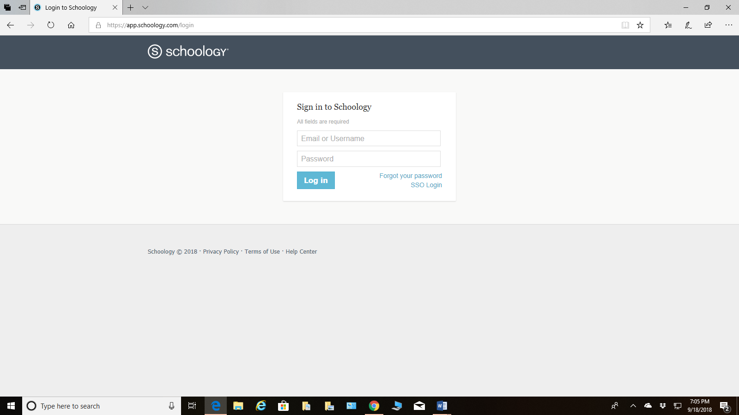  Forgot Password
How do I get the access code to join my child's Schoology course? | The Skyward family access account is already associated with all of your children and their teachers so there is no need for different access codes to join Schoology.
How do I see my different children? | To view your other children in your Parent Access account click on the white arrow (fairly light) or your child’s name at the top. It should pull up your other children. You can then click on the child and see their Schoology profile and courses. The black arrow below is pointing to the white arrow or your first child’s name. When I click on it, I see the other children.  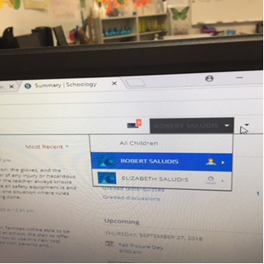  *You do not need an access code to add a child. Click on the white arrow.
Does Schoology have a mobile app?  How do I login to the mobile app?  *Your email login to mobile or web version of Schoology should be the same email in Skyward. | Yes, when you are accessing Schoology for the first time, you will need to do that on the website: app.schoology.com  The Schoology app is available for download from the Apple App Store, Android App Google play or Amazon app on kindle fire.  When you download the app and get ready to login DO NOT SELECT FBISD for search through school. Only students select FBISD to login through the mobile app.  You will click on CONTINUE and enter only your Email and Password on the next screen.  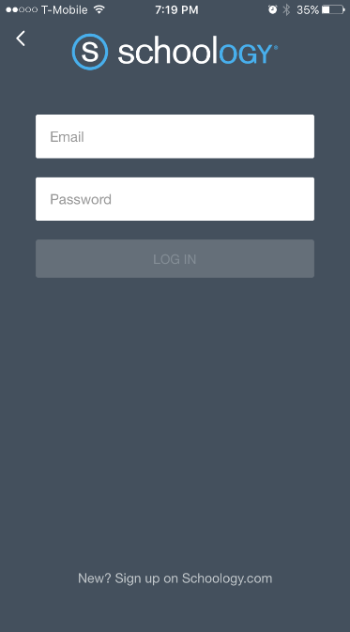  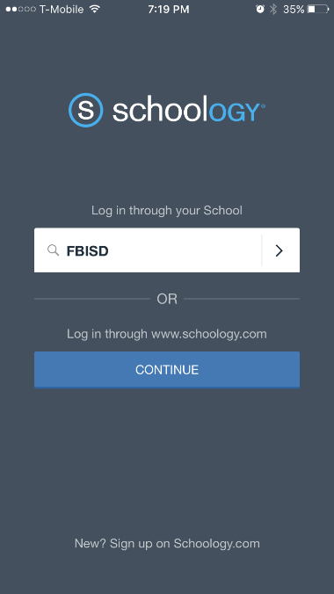
Who do I contact when I need help? | If you would like more help with Schoology, email our support desk at csc@fortbendisd.com or all 281.634.1300.

