3rd Grade Literary Nonfiction Study Guide for Practice

Directions: Read the passage and answer the questions that follow.

Ben Franklin and His First Kite

1 Ten-year-old Benjamin Franklin was hard at work in his father’s candle shop. He was cutting wicks. He carefully laid out each one.

2 Ben stretched his arms and let out a yawn. Candles could be tall or short, fat or thin, and even different colors. But there was nothing fun about candles for Ben.

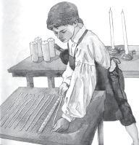
3 “When do you think we’ll be done today?” Ben asked his father.

4 “Soon enough,” his father answered. “Why? Do you have special plans?”

5 Ben’s father smiled.

6 It was a rare day indeed when Ben did not have a plan in mind.

7 “Yes,” said Ben. “I want to try an experiment at the millpond.”

8 “You’ll be swimming, then?” his father asked.

9 Ben grinned. “Partly,” he said.

10 His father nodded. Ben was a fine swimmer. That afternoon Ben flew down the streets of Boston. He was headed for home. Along the way he noticed the waves cresting in the harbor. The ships rocked back and forth. That was good, he thought. He needed a strong wind today. When Ben got to his house, his mother met him at the door. Inside, two of his sisters were busy making hasty pudding by the hearth. Ben had sixteen brothers and sisters.

11 “Ben,” his mother said, “why are you in such a hurry?”

12 Ben told her about his plan.

13 “Since your father approves, I won’t keep you,” said his mother.

14 “Just be back for supper.”

15 Ben nodded. He ran to get the kite he had made the week before. Then he left the house. At the millpond a few of Ben’s friends had arrived to watch.

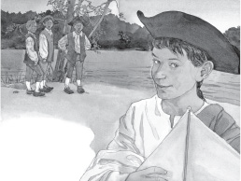

16 “You’ve picked a poor place to fly a kite,” said one.

17 Ben shrugged. “I’m doing an experiment,” he said.

18 Ben got undressed. He gave his clothes to one of his friends.

19 “Please carry these to the other side of the pond,” he said.

20 “What are you going to do?” asked the other boys. “Carry the kite while you swim?”

21 “No,” said Ben. “The kite is going to carry me.”

22 “But that kite’s nothing special. It’s just paper, sticks, and strings,” said one boy.

23 “That’s true,” Ben said. “But you see, the kite isn’t the invention. The invention is what I’m going to do with it.”

24 Ben raised the kite in the air. Once the wind had caught and carried it aloft, Ben walked into the water. There he lay on his back, floating.

25 “I’m going to cross this pond without swimming a stroke,” said Ben.

26 The wind tugged on the kite. The kite string tightened. The water began to ripple at Ben’s feet. The kite was pulling him!

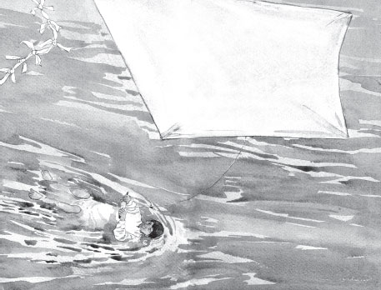

27 The boys whooped and hollered as Ben glided across the pond. Finally he reached the other side. The other boys met him there.

28 “That was amazing!” said one.

29 “You crossed the whole pond without swimming a stroke,” said another.

30 “What will you do next?” they asked.

31 “Another invention?”

32 “A different experiment?”

33 Ben didn’t know. But he was sure he would think of something.

Questions

1. Ben wants to be finished working with his father because he—

A. is sleepy
B. has plans for an experiment
C. is hungry
D. wants to play with his friends

2. The first place Ben goes after leaving his father is to—

A. the pond
B. his friend’s house
C. the candle shop
D. his home

3. Which sentence best describes Ben?

A. He likes to try new things.
B. He wants to make candles when he grows up.
C. He likes making people laugh.
D. He wants to spend more time with his family.

4. What happens after Ben gets his kite to fly?

A. The kite falls into the water.
B. Ben takes the kite to the pond.
C. The kite pulls him across the pond.
D. Ben plans his experiment.

5. Which sentence best tells what this story is about?

A. Ben likes to do many things with his brothers and sisters.
B. Ben works hard each day in his father’s candle shop.
C. Ben learns that candles are more important than kites.
D. Ben finds a way to cross the pond without swimming.

6. Read the sentences below. What is the meaning of the word millpond?

“Yes,” said Ben. “I want to try an experiment at the millpond.” “You’ll be swimming, then?” his father asked.

A. water pond
B. sand dune
C. grassy hill.
D. tree house

7. Read the sentence. What is the meaning of the word cresting?

Along the way he noticed the waves cresting in the harbor. The ships rocked back and forth.

A. slowing down to a stop
B. rising higher and hitting against something
C. remaining calm and not moving
D. flowers blooming.

8. How did Ben feel when he got his kite to fly and move him across the pond?

A. He was not happy
B. He was afraid
C. He was very happy
D. He was worried

9. In this story Ben can best be described as an—

A. explorer
B. farmer
C. inventor
D. traveler

10. Read the sentences. What is the meaning of the word tugged?

The wind tugged on the kite. The kite string tightened.

A. to drop something on the ground
B. to take apart and put back together
C. to cut a string away from an object
D. to pull at and move something

3rd Grade Literary Nonfiction Study Guide Anchor Chart

