Name: ______________________________________ Date: ________________________

Student Exploration: Fan Cart Physics

Vocabulary: acceleration, force, friction, mass, newton, Newton’s second law
Prior Knowledge Questions (Do these BEFORE using the Gizmo.)
- Imagine a horse pulling a cart. What would happen to the speed of the cart if several bags of cement were added to the cart? _______________________________________________

- Suppose several more horses were hitched up to the same cart. How would this affect the speed of the cart? __________________________________________________________
Although these questions may seem simple, they form the basis of Newton’s second law of motion. The Fan Cart Physics Gizmo™ can be used to illustrate all three of Newton’s laws.

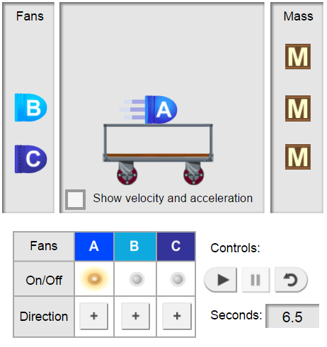

Gizmo Warm-up
The Fan Cart Physics Gizmo™ shows a common teaching tool called a fan cart. Place fan A on the cart and turn it on by clicking the ON/OFF button below.
- Look at the blue lines coming from the fan. In which direction is the air pushed? ____________________
- Press Play () and observe the cart. In which direction does the cart move? __________________
By blowing to the left, the fans exert a force on the cart
that pushes it to the right. This illustrates
Newton’s third law: A force in one direction results
in an equal force in the opposite direction.

- The velocity (v) of the cart is its speed and direction. Click Reset (). Select the BAR CHART tab, and click Play. Does the velocity change or stay the same? _______________
A change in velocity is called acceleration (a).

Activity B:  Newton’s second law | Get the Gizmo ready:  - Click Reset.  - Set the Initial velocity of cart to 0.0 m/s.  - Place three fans on the cart, all blowing to the left. | 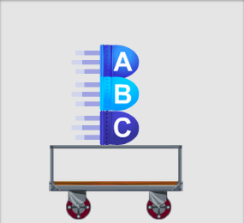

Question: How do mass and force affect acceleration?

- Experiment: Turn on the fans. Click Play and watch the cart, then select the TABLE tab.
- Scroll to the bottom of the table. What is the final velocity of the cart? ____________
- How long did it take the cart to reach the end of the track? _____________________

- Calculate: Acceleration is a measure of how much the velocity of the cart changes each second. To calculate acceleration, divide the final velocity by the amount of time it took to reach that velocity. The units of acceleration are meters per second per second, or m/s².
- What is the acceleration of the cart? (Include units.) __________________________
- Check your answer on the TABLE tab. Were you correct? _____________________

- Form hypothesis:

- How do you think changing the mass of the cart will affect its acceleration?
___________________________________________________________________
- How do you think the number of fans will affect the cart’s acceleration?
________________________________________________________________

- Experiment: Select the BAR CHART tab and turn on Show numerical values. For each of the situations below, record the acceleration of the cart.

Load | Number of fans turned on | Acceleration
3 fans, 0 mass units | 1
3 fans, 0 mass units | 2
3 fans, 0 mass units | 3
3 fans, 2 mass units | 1
3 fans, 2 mass units | 2
- fans, 2 mass units | 3

5. Analyze: Look at the acceleration values.

- How did doubling the force affect the acceleration of the cart? __________________

___________________________________________________________________
- Compare the first and third lines of data. How did tripling the force affect the acceleration of the cart? _______________________________________________
- A cart with two mass units and three fans has twice the mass as a cart with just three fans. How did doubling the mass affect the acceleration of the cart? _____________
___________________________________________________________________

- Draw conclusions: Newton’s second law states that force is equal to mass times acceleration: F = ma. This law can be rearranged as a = F or a = F ÷ m.
m

How does this experiment demonstrate Newton’s second law? _______________________

_________________________________________________________________________

7. Challenge: The unit of force is the newton (N). One newton is the force required to accelerate a 1-kg object at a rate of 1 m/s².

A. Suppose each fan supplies a force of 2 N. Use Newton’s second law equation, F = m x a, to find the mass of a cart that accelerates 0.8 m/s² ^{(show your work with GUESS)}
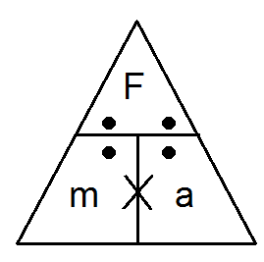
B. Find the acceleration of the cart if the Force applied is 10N and its mass it 20 kg. ^{(show your work with GUESS)}

