PrepSTEP: Preparing to take the TSIA
- Go to the “Library Media Services” tab on the RPHS homepage.
To get there: fortbendisd.com /Schools / Ridge Point High School

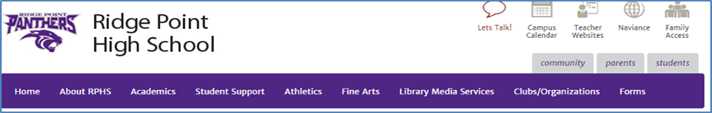

- Under “Most Popular RPHS Links”, click the PrepSTEP link:
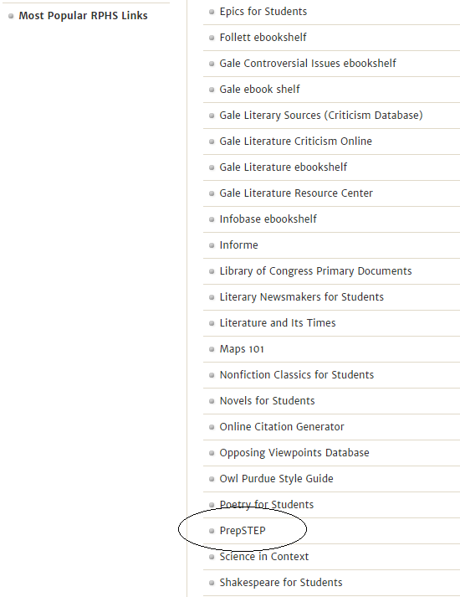

3. Log in or Register if a first time user.
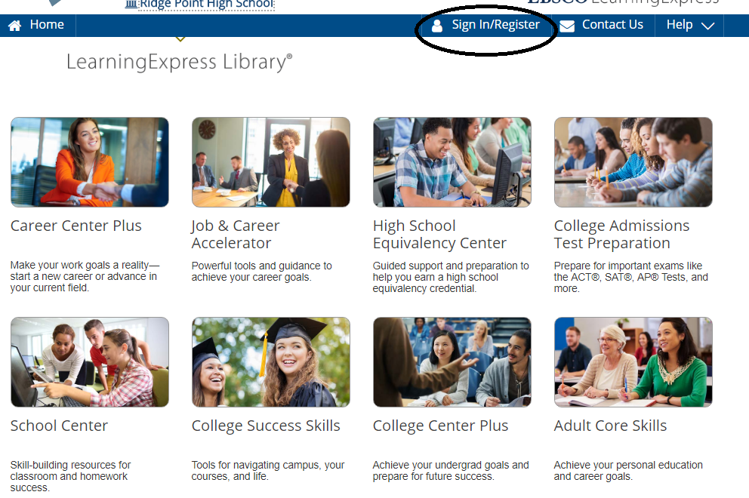
First time users: REGISTER using your school email and set your password.
Returning Users: This will be the Login each time you access PrepSTEP.
- To locate TSIA practice tests, select the High School Students and select Practice for State Tests.
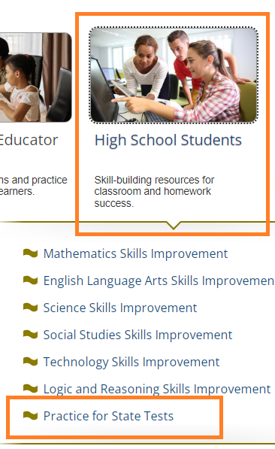

- Select TSIA Practice Tests.
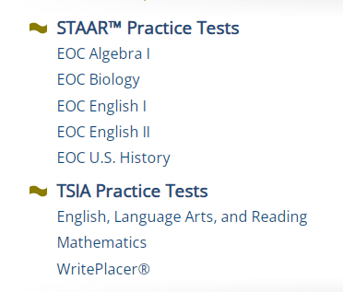

5. Scan the QR code to jump to the link if using a camera enabled device.


If prompted, select Fort Bend ISD from the pulldown menu.
Password: 3duc*t3

