**Project Ideas**

Below is a list of ideas that you can use to answer the BIG Idea question for a unit. This is about more than just looking pretty… you must answer the essential questions, addressing the historical context, synthesizing by relating the topic to another time in U.S. history, as well as linking to the AP US History themes, or BAGPIPE. You’ll find the rubric on page 2.

In an effort to reduce paper waste, please consider a digital method of completing this activity.

PLEASE REMEMBER THE FOLLOWING:

* You may have one partner if your format lists that as possible.
* Your partner does NOT need to be within your period
* The file name should be in the following format “partners names/project title” (Ex: Batman,Robin-Roaring Twenties)
* Don’t delete the project from your drive until I’ve graded it
* If you are worried that your BAGPIPE themes or synthesis isn’t clear in your project, especially something like a song, feel free to have a separate explanation slide or page
* **Projects should be Shared or sent to** [**tenczarkhs@gmail.com**](mailto:tenczarkhs@gmail.com)

|  |  |
| --- | --- |
| Essay (typed in Google Docs and Shared) | Poster or digital bulletin board (digital, no posterboards please; you can use Slides by changing the dimensions [HERE](http://www.alicekeeler.com/teachertech/2016/02/24/google-slides-rotate-to-portrait-mode/), or something else like [Padlet)](https://padlet.com/) |
| Video/News report (**partner**) | Infographic ([Venngage](https://venngage.com/), [Piktochart](http://piktochart.com/), [Canva](https://www.canva.com/create/infographics/)) |
| Comic/storyboard ([StoryboardThat](http://www.storyboardthat.com/)) | Digital newsletter, at least 4 written sections and visuals (**partner**) |
| Song (**partner**), must be recorded and available to view/hear anywhere, so I recommend posting to [YouTube](https://www.youtube.com/) or playing on your computer and using [ScreenCast](https://screencast-o-matic.com/home) to record the performance;, lyrics need to be appropriate and turned in | Historical interview (**partner**) |
| Interactive lesson ([Blendspace](https://www.tes.com/lessons)) (**partner**) | Presentation ([Prezi](https://prezi.com/) or Google Slides, including presenter notes) *You may work with a **partner** **IF** you incorporate something else like a video, infographic, comic, or historical interview |

**BIG Idea Rubric**

* Turning in a project that relates to the topic starts you out at a 70. From there you will earn the remaining points to get up to 100. Use this while making, or at least to check over your project.
* Failure to answer the prompt or question could result in less than a 70
* Turning in a day late will result in a 10pt deduction, 2 days late is -20, any time after that is -50pts
  + If you are absent on the due date, it should still be turned in online.

|  |  |  |  |  |
| --- | --- | --- | --- | --- |
|  | 5 | 3 | 1 | 0 |
| **Accuracy**  Are your facts correct? | No factual errors | N/A | There are some factual errors |  |
| **BAGPIPE**  Did you relate your information, or the overall topic to the APUSH themes in BAGPIPE? | Explains relationship to at least at least 4 of the APUSH themes | Explains relationship to 3 APUSH themes; or mentions 3 but fails to explain connections | Briefly mentions 2 APUSH themes | Briefly mentions 1 APUSH theme or is missing them completely |
| **Communication**  Is your message clear? Are their spelling and grammatical errors? | No questions on what is trying to be said, no spelling or grammatical errors. | Some minor questions on what is being said, some spelling or grammatical errors. | Message is hard to understand, and/or significant spelling or grammatical errors. |  |
| **Creativity & Neatness**  Is the product original, does it present new thoughts/ideas? Essay and simple presentation will score a maximum of 3 here.  Did you choose good font/background colors? Do you have too much text? | Presentation is something new and/or gives a unique or interesting perspective.  Fonts are contrasting, no overload of text or visuals, everything is spaced well. | Presentation is in a common format (simple essay or presentation), but is good. Nothing unique, but a solid presentation.  Occasional quality control issues, but does not detract from the project. | No evidence of new thoughts or perspectives in the product. Simply presents facts. | Serious quality issues that detract from the project. |
| **Essential Questions**  Are all essential questions answered thoroughly? | Answers 100% of the attached questions adequately. | Answers at least 75% of the attached questions adequately. | Answers at least 50% of the attached questions adequately. | Answers less than 50 % of the attached questions |
| **Synthesis**  Did you relate to another time period in U.S. history? | Clearly linked the topic to another time period in U.S. history. | Mentioned another period but did not clearly establish a link. |  | Does not mention any other time periods. |

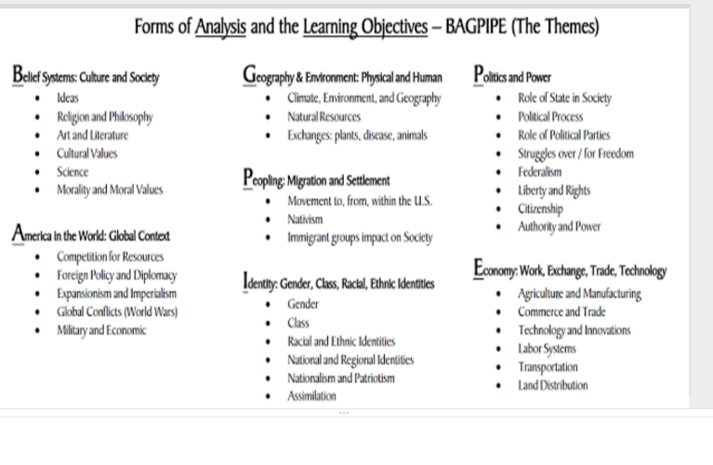

**Pick ONE topic for your project.**

* + U.S. Expansion and Imperialism
    - What territories did the United States acquire during the late 19th and early 20th centuries? How did we acquire each territory?
    - What were the arguments for and against territorial acquisition? Who were the strongest supporters of each side?
    - How was the United States, a fairly isolated country, able to acquire these new territories?
    - How does this new imperialism change America’s status in the world?
    - How does the U.S. military change at this time?
    - What is the relationship between the Roosevelt Corollary and the Monroe Doctrine of 1823?
  + The Progressives
    - Identify the various Progressive movements and their leaders
    - Explain what led to the explosion of progressive movements in the late 19th and early 20th centuries.
    - What reforms were made to governments at the local, state, and national level?
  + World War I
    - Explain what led to U.S. involvement in World War 1.
    - Why did Wilson face so much opposition to his 14 Point Plan (from the European nations) and the League of Nations (from the American people)?
    - Explain some of the domestic effects of the war on America; cultural, economic, etc.
  + Roaring Twenties:
    - How did nativist sentiment come manifest itself during this period?
    - Explain the various conflicts that were seen during the 1920s.
    - How did new technology influence and impact society during the 1920s?
    - Explain the changes that both African Americans and women saw.
    - How does the American consumer culture grow?