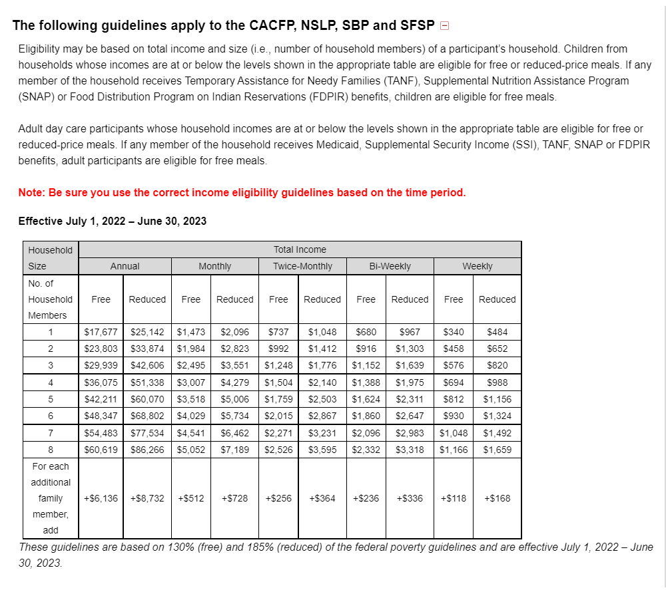
Source: https://squaremeals.org/FandNResources/IncomeEligibilityGuidelines.aspx 03/31/2022

