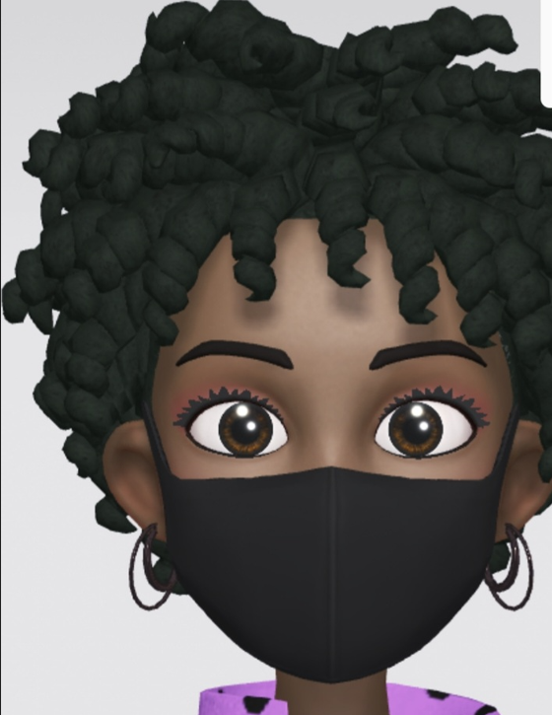



To contact me, email me at [auhora.riley@fortbendisd.com](mailto:auhora.riley@fortbendisd.com)

My room number is 803 and the telephone number is 281-329-6551