Display:
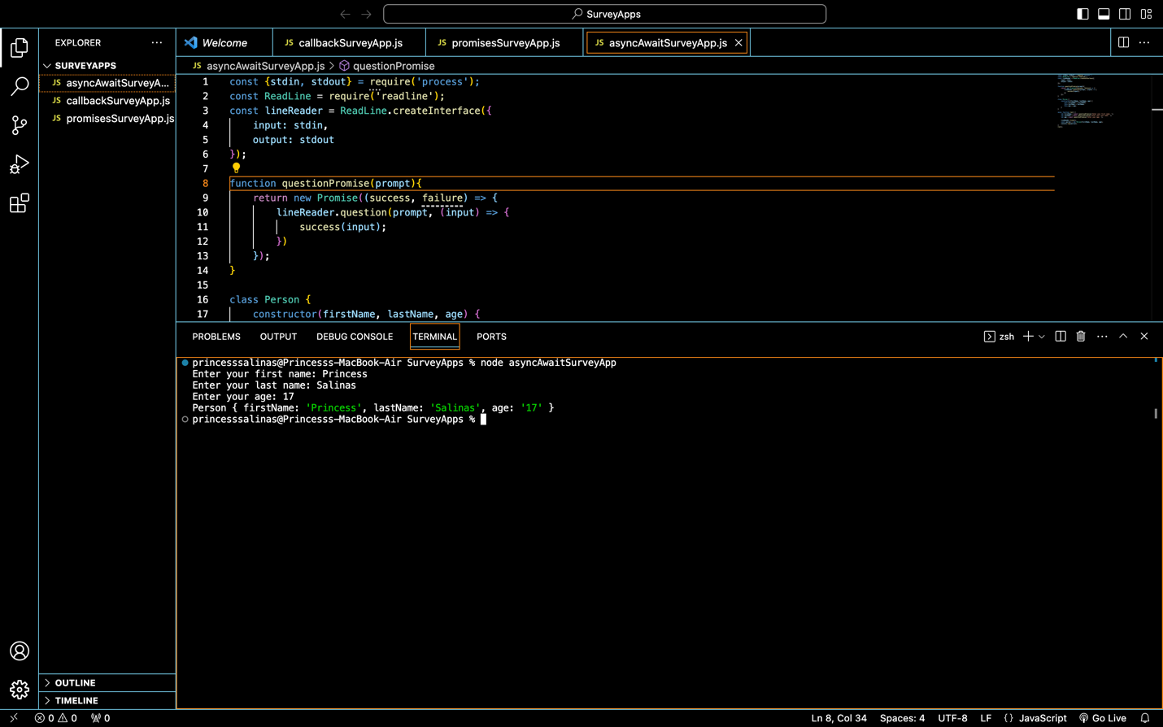

Code:
asyncAwaitSurveyApp.js:
const {stdin, stdout} = require('process');
const ReadLine = require('readline');
const lineReader = ReadLine.createInterface({
input: stdin,
output: stdout
});

function questionPromise(prompt){
return new Promise((success, failure) => {
lineReader.question(prompt, (input) => {
success(input);
})
});
}

class Person {
constructor(firstName, lastName, age) {
this.firstName = firstName;
this.lastName = lastName;
this.age = age;
}
}

async function run() {
let firstName = await questionPromise('Enter your first name: ');
let lastName = await questionPromise('Enter your last name: ');
let age = await questionPromise('Enter your age: ');

lineReader.close();
const person = new Person(firstName, lastName, age);
console.log(person);
}
run();

callbackSurveyApp.js:
const ReadLine = require('readLine');
const lineReader = ReadLine.createInterface({
input: process.stdin,
output: process.stdout
});

class Person {
constructor(firstName, lastName, age){
this.firstName = firstName;
this.lastName = lastName;
this.age = age;
}
}

let firstName = "";
let lastName = "";
let age = 0;

lineReader.question('Enter your first name: ', (input) => {
firstName = input;

lineReader.question('Enter your last name: ', (input) => {
lastName = input;

lineReader.question('Enter your age: ', (input) => {
age = input;

console.log(new Person(firstName, lastName, age));
lineReader.close();
});
});
});

promisesSurveyApp.js:
const { stdin, stdout } = require('process');
const ReadLine = require('readline');
const lineReader = ReadLine.createInterface({
input : stdin,
output: stdout
});

function questionPromise(prompt){
return new Promise((success, failure) =>{
lineReader.question(prompt, (input) => {
success(input);
})
});
}

class Person {
constructor(firstName, lastName, age) {
this.firstName = firstName;
this.lastName = lastName;
this.age = age;
}
}

let firstName;
let lastName;
let age;
questionPromise('Enter your first name: ')
.then(entry => {
firstName = entry;
return questionPromise('Enter your last name: ')
}).then(entry => {
lastName = entry;
return questionPromise('Enter your age');
}).then(entry => {
age = entry;
console.log(new Person(firstName, lastName, age));
})
.catch(err => {
console.log(err);
})
.finally(() => {
lineReader.close();
});

