Display:
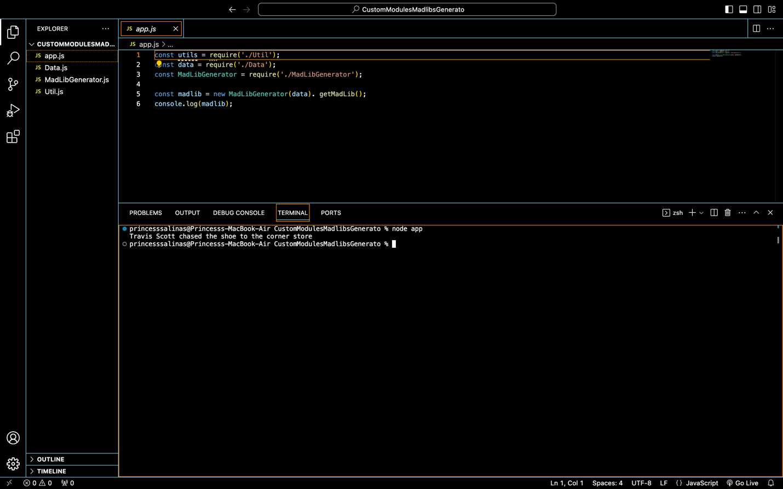

Code:
App.js:
const utils = require('./Util');
const data = require('./Data');
const MadLibGenerator = require('./MadLibGenerator');

const madlib = new MadLibGenerator(data). getMadLib();
console.log(madlib);

Data.js:
//sample sentence: I rode my bike to the corner store
const Data ={
subject:["Justin Bieber", "Zendaya", "Travis Scott"],
verb:["walked", "crawled", "chased"],
object:["laptop", "brush", "shoe"]
}

module.exports = Data;

MadLibGenerator.js:
const {getRandomArrayValue} = require("./Util");

module.exports = class MadLibGenerator {
constructor(data){
this.subject = getRandomArrayValue(data.subject);
this.object = getRandomArrayValue(data.object);
this.verb = getRandomArrayValue(data.verb);
}

getMadLib(){
return `${this.subject} ${this.verb} the ${this.object} to the corner store`;
}
}

class MadLibGenerator {
constructor(subject, verb, object){
this.subject = subject;
this.verb = verb;
this.object = object;
}

getMadLib(){
return `${this.subject} ${this.verb} the ${this.object} to the corner store`;
}
}

Util.js:
module.exports = {
getRandomArrayValue: function getRandomArrayValue(arr){
let randomIndex = Math.floor((Math.random() * arr.length));
return arr[randomIndex];
},
getLastValue: function getLastValue(arr){
return arr[arr.length-1];
}
}

