**World History**

**Dulles High School**

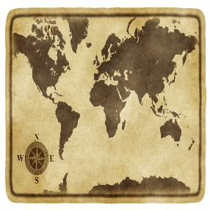

**Course Syllabus**

**Teacher: Mr. Erekson**

**E-Mail: jonathan.Erekson@fortbendisd.com**

**Conference Period: 4th Period**

**Phone: 281-634-7560**

**Tutorials: Tuesday/Thursday 2:50-3:20. Please let me know if you plan on attending.**

**Purpose of this Course:**

Welcome to World History! The study of World History is a survey of the global history of humankind. Due to the expanse of world history and the time limitations of the school year, the scope of this course will focus on “essential” concepts and skills that can be applied to various eras, events, and issues from the earliest times to the present. Traditional historical points of reference in world history are identified as students analyze important events and issues within civilizations across all parts of the world.

**Grading Procedures:**

⃰At least **three major grades** will be given each nine weeks. Objective tests will consist of a combination of multiple-choice, matching, and true-false questions. Tests will be averaged and will count as 50% of the nine-week grade.

⃰At least **nine daily grades**, including quizzes and written assignments, will make up the remaining 50% of the nine-week grade.

**Grading scale:**

**A: 90-100**

**B: 80-89**

**C: 70-79**

**F: 69 and below…**

**Materials**

You will need the following supplies in class:

1. **1 ½ inch Binder**
2. **Blue or Black Pen**
3. **Pencil**
4. **Paper**
5. **Colored Pencils**

\***All of these items are subject to change.**

**Textbook**

We have a set of in class textbooks that are not to leave the room. You can also check out a textbook from the school. Since there is no longer online access for our textbook, we will be using Active Classroom. Information about that will be given in class.

**Cell Phone Procedure**

**DHS will not allow cell phones or earbuds in the class this year for any reason.** Students will face disciplinary consequences for violating this rule. Students may bring their own laptop or tablet to use during class time with teacher permission for assignments.

\***All of these items are subject to change.**