**School Supply List**  
**SAILS**

MC900229657[1]

Functional Academics

Mrs. Crowson-Wagner

*2- one inch 3 ring binder.

*2 – spiral notebooks

*2 – Tabbed Dividers (5 tabs)

* 1 - pair of scissors

* 2 - boxes of #2 pencils (12pack)

* 1 - Plastic pencil box that snaps shut

* 2 - box of colored pencils

* 8 - Glue sticks

* 1 - pink eraser

*1 - ruler

*3 – construction paper (8.5x11)

* 4 -boxes of Kleenex

* 2 – containers of hand sanitizer

*1 – Wetones

**\*\*As needed we may ask for additional school supplies throughout the school year\*\***



# August 22, 2017

# Dear Parent(s)and Guardian(s),

It seems like just last month we were preparing for summer and now here we are beginning another exciting year in high school. I hope that your summer was wonderful and restful. It is indeed a pleasure to have your child in my class. To start off the year right, I am sending you this Parent Survival Handbook that has been assembled to help you understand the homework requirements, class room routines and other vital information that will enable us to make this a very positive and rewarding year. I feel as though open lines of communication between the parent, student, and teacher are the key to promoting an educational climate that is conducive to learning. I am looking forward to working with you and your child. We have a team of three SAILS teachers, Mrs. Crowson-Wagner, Dr. Kiser and Mr. Long. We each have two amazing Paraeducators that work with each individual teacher. Dr. Kiser teaches the Vocational, Career Prep and Science Classes. Mr. Long teaches Math classes and also the Career Prep and Vocational. Ms. Crowson-Wagner teaches the History classes as well as the English classes and Occ Prep class. Together we can make a difference!

Please feel free to contact me at any time if there is a question or situation you would like to discuss. You will receive additional communication throughout the school year regarding any upcoming projects and or activities we will be doing in class. Since everything in SAILS (formally known as LIFEskills ) is also based on individual needs this information is just to provide you some of the best practices for our classroom to be successful. Some of this information may not be applicable to your child. Please feel free to leave me any comments below or email me and we will modify according to best meet the needs of your child.

I look forward to building a relationship with you and your child and thus providing the best education that we are capable of giving.

Sincerely,

Robyn Crowson-Wagner

Robyn Crowson-Wagner

Your child will have assignments during the school day for which he or she is responsible. Due to uncertain circumstances, if your child for any reason is unable to complete an assignment, this will automatically become homework to be completed at home and returned to school the following day. It is the student’s responsibility to return work.

Project due dates will be posted and will be written down in agendas. Students are expected to adhere to these due dates as well. Please talk to your child about the importance of completing assignments.

☺☺☺☺☺☺☺☺☺☺☺☺☺☺☺☺☺☺☺

Reading

Our reading program incorporates many different components. Students will be participating in Guided Reading Groups, Whole Group Instruction and Independent Reading.

Students may have the opportunity to participate in Literature Circles (group discussion about a common book) in the school library.

Independent Reading

Students will be accountable for silent reading. Students will have time in class to read at the beginning of each reading class and when not in guided reading groups. While some students may not be able to read, they will be encouraged to practice reading and will be given books that they may enjoy to look at an engage in. Every other week the students will check out two books from the school library, one book will be teacher preference and the other will be students’ choice.

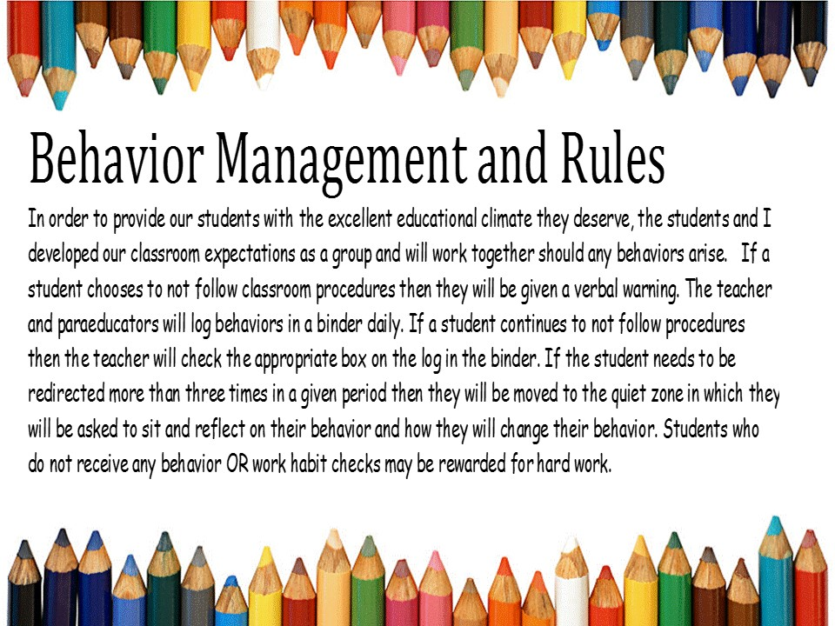

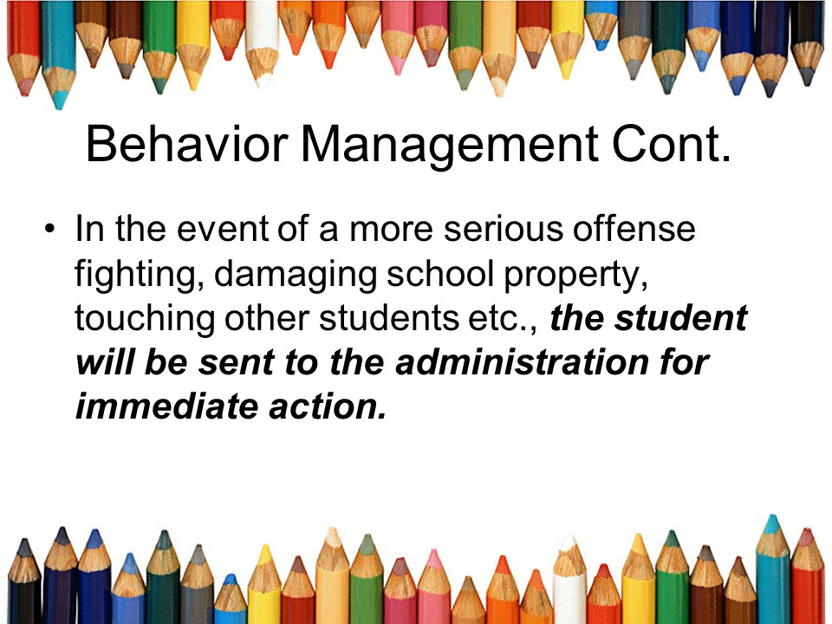

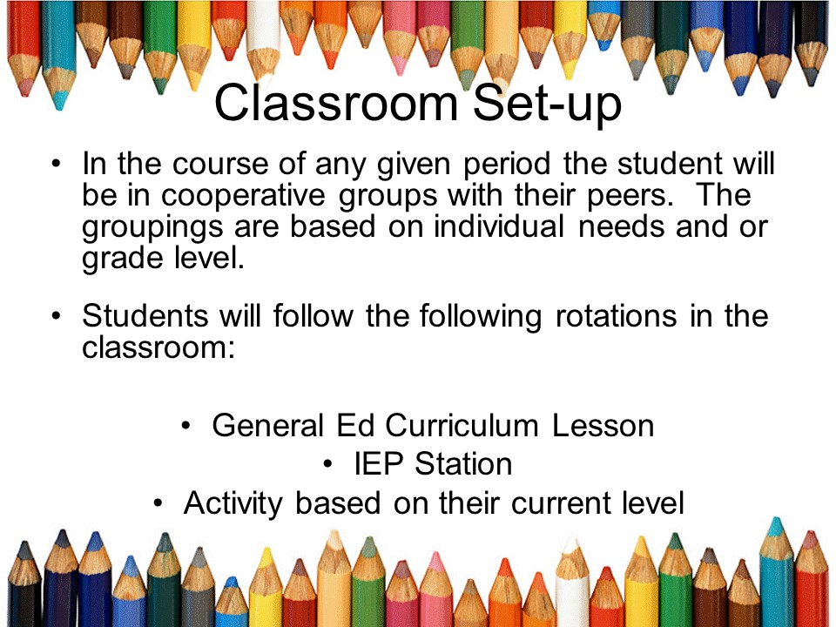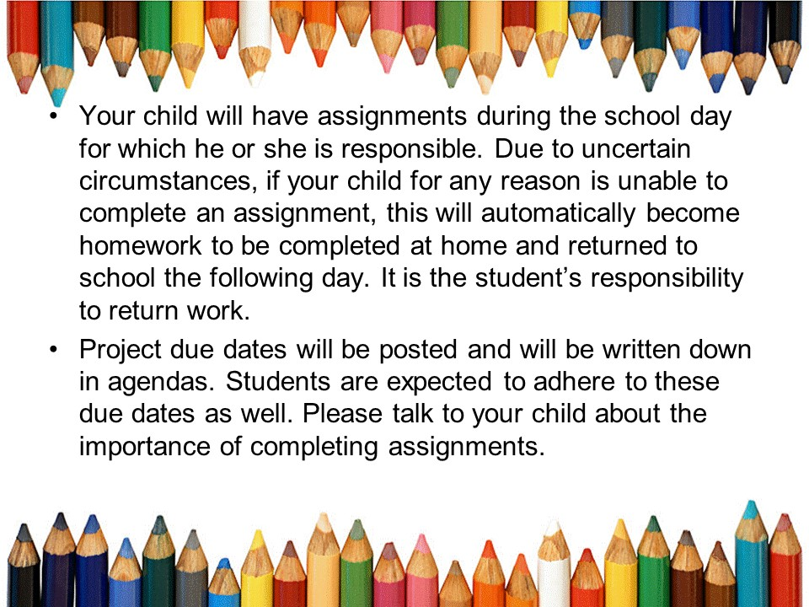

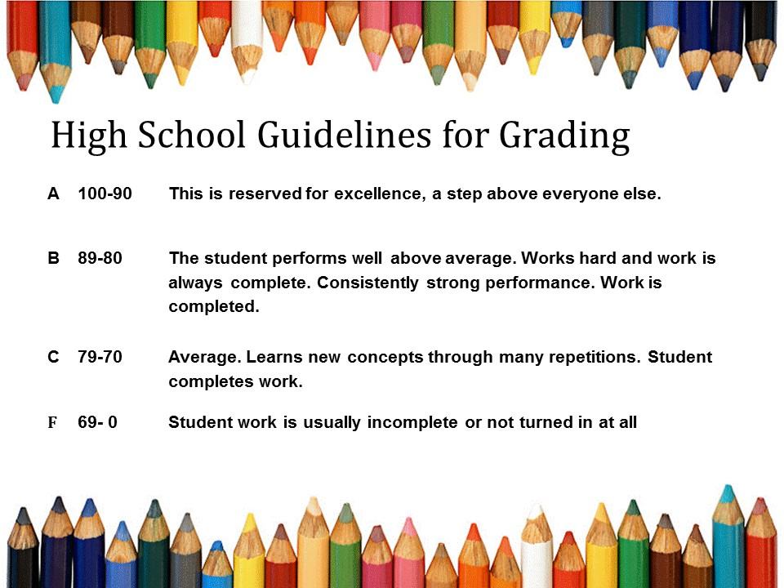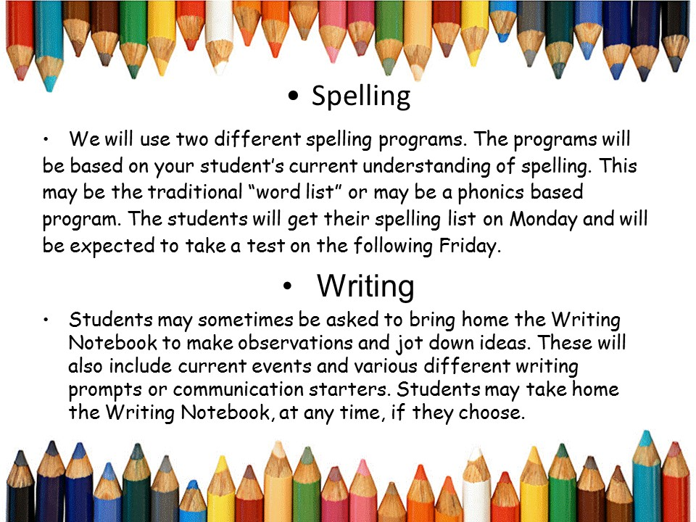

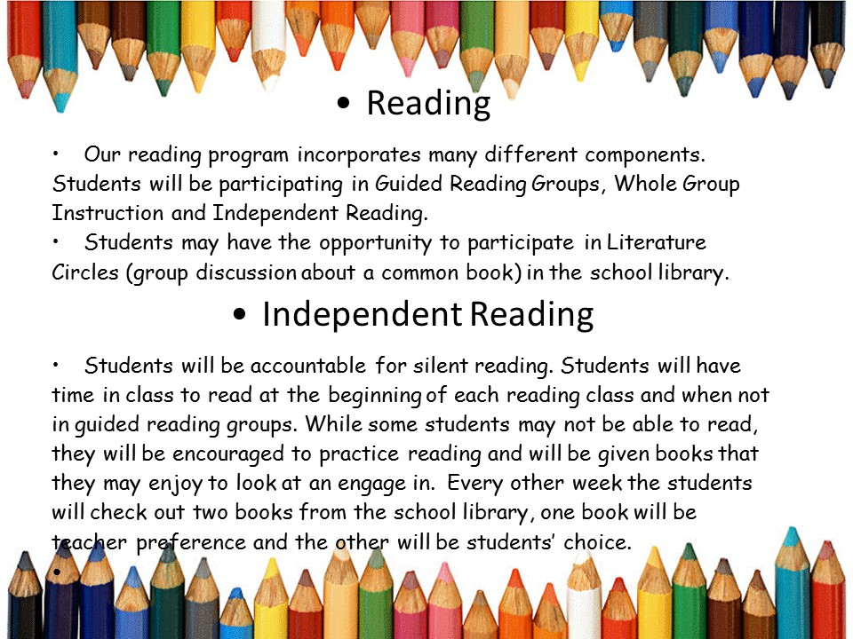





Additional Information

Room Parents

Please let me know if you are interested in volunteering and I will be in touch with you regarding opportunities.

Lunch with your student

A school-wide policy has been adopted regarding lunch at this time and parents are asked not to come up for lunch.

Snacks

Each class has a snack time included in the schedule at the end of the day. If there is something specific that your student needs please feel free to send that to school with them. Also, if you would like your student to have their own water bottle they may also bring that to school.

Conferences

If you would like to schedule a conference, please send a note with your child or an e-mail. We will try to coordinate a time that is convenient for everyone involved. Again, since everything in SAILS is also based on individual needs this information is just to provide you some of the best practices for a successful classroom. Some of this information may not be applicable to your child. Please feel free to leave me any comments below or email me and we will modify according to best meet the needs of your child.

==============================================================

I have read the Parent Survival Handbook and discussed the necessary content with my child.

Parent/ Guardian Signature

________________________________

Child’s Name_______________________

Date _________________email__________________

Comments_________________________________________

_________________________________________________

_________________________________________________

_________________________________________________

I have read and discussed the discipline procedures with my child.

Please sign and return to school.

__________________

Parent Signature

______________________

Child Signature

Room Parents

Please let me know if you are interested in volunteering and I will be in touch with you regarding opportunities.

Lunch with your student

A school-wide policy has been adopted regarding lunch at this time and parents are asked not to come up for lunch.



