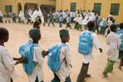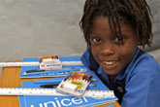

Why UNICEF?


- You will learn how UNICEF has saved more children's lives than any other humanitarian organization.
- You will be kept up-to-date on UNICEF's work in emergencies such as natural disasters and armed conflict crises.
- You will gain access to volunteer-only resources and publications as well as special events and opportunities.
- You will be able to directly engage and network with other volunteers
in their Action Center.
The most important benefit to volunteering with the U.S. Fund is knowing that you are contributing in the fight for child survival.
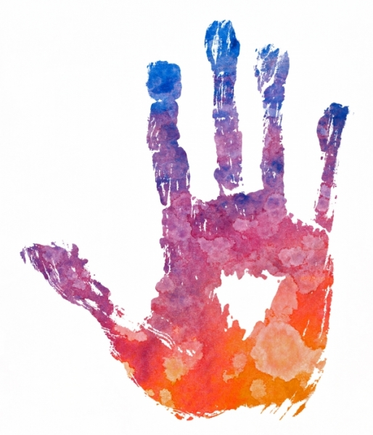The BE UNICEF High School Club program is a youth-led initiative that partners with the U.S. Fund for UNICEF to educate, advocate, and fundraise for UNICEF’s lifesaving work.
It is a growing movement rooted in a belief that students have a vital role to play in helping the world’s children survive. The initiative supports UNICEF’s child survival work in more than 150 countries, because students have a unique opportunity to engage members of their community on global humanitarian issues.
BE UNICEF High School Clubs set up booths at their schools and at festivals to promote children’s issues and fundraise, write letters to elected officials, and participate in Trick-or-Treat for UNICEF and the UNICEF Tap Project campaigns with local elementary schools. They also produce benefit concerts, host international coffee hours, and write school newspaper editorials on UNICEF’s work.
Few issues are as important as making sure small children in the developing world survive diseases that are easily preventable elsewhere. This goal can be accomplished, but it will take a lot of hard work. UNICEF’s High School Clubs affirm the power of young people to make a major difference.

