STAAR Practice tests in the Cambium System

[www.texasassessment.gov](http://www.texasassessment.gov)

Student and Families

cid:image001.png@01D7D62C.1CF348D0

Scroll down to How to Help Prepare Your Child

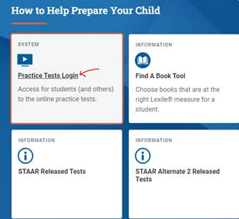

Practice Online Test Login. Just click sign in at the bottom ONLY

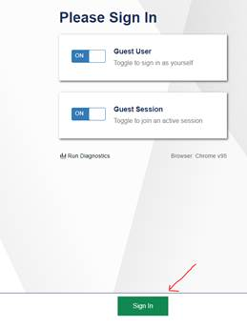

Select Grade Level and Test

**Overview of the Test Site for the Texas Assessment Program**

Sample Test Page

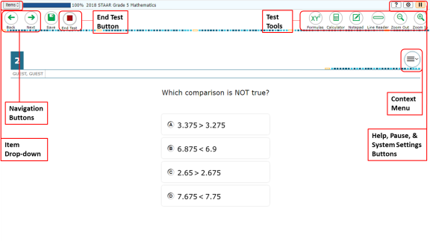

There are two types of test tools available:

* **Global Tools**: These tools appear in the global menu at the top of the test page.
* **Context Menu Tools**: These tools are for passages and questions. To use these tools, click the context menu Context Menu.

| **Global Tools** | **Instructions** |
| --- | --- |
| **Help button**  **help button** | To view the on-screen window, select the question mark Online Help Button button in the upper-right corner. |
| **Calculator**  **Calculator tool** | To use the on-screen calculator, select **Calculator** in the global menu.  The calculator may be basic, scientific, or graphing based on the test and provided accommodation  The calculator tool is available for the following tests:   * Texas Instruments Basic: Mathematics Grades 3 – 7, and Science Grade 5 * Texas Instruments Scientific and Texas Instruments Basic: Science Grade 8, and Biology * Texas Instruments Graphing and Desmos Graphing: Mathematics Grades 8, Algebra I |
| **Dictionary**  **Dictionary Tool** | To search the Merriam-Webster dictionary or thesaurus, select **Dictionary** in the global menu. |
| **Line Reader**  **Line Reader Tool** | To highlight an individual line of text in a passage or question, select **Line Reader** in the global menu.  If the enhanced line reader mode is enabled, all content except for the line in focus is grayed out for greater emphasis.  This tool is not available while the Highlighter tool is in use. |
| **Notepad**  **notas** | To enter notes in an on-screen notepad, select **Notes** in the global menu. |
| **Periodic Table**  **tabla periodica** | To view the on-screen periodic table, select **Periodic Table** in the global menu. |
| **System Settings**  **configuracion del sistema** | To adjust audio volume during the test, select the cog wheel icon cog wheel icon in the upper-right corner. |
| **Zoom buttons**  **zoom in button zoom out button** | To enlarge the text and images on a test page, select **Zoom In**. Multiple zoom levels are available. To undo zooming, select **Zoom Out**. |

| **Context Menu Tools** | **Instructions** |
| --- | --- |
| **American Sign Language**  **American Sign Language Icon** | You can watch videos that translate test content into American Sign Language (ASL). To view ASL videos:   1. From the context menu, select **American Sign Language**.    * If only one ASL video is available, the video opens automatically.    * If multiple ASL videos are available, sign language icons American Sign Language Icon appear next to the test content for each video. Select the icon for the test content you wish to translate into ASL.   *Note: This tool requires you to have the ASL accommodation turned on.* |
| **Highlighter**  **highlighter tool**  **Reset Highlighter tool** | To highlight text, select the text on the screen and then select **Highlight Selection** from the context menu. If multiple color options are available, select an option from the list of colors that appears.  To remove highlighting, select **Reset Highlighting** from the context menu.  You cannot highlight text in images. |
| **Mark for Review**  **mark for review tool** | To mark a question for review, select **Mark for Review** from the context menu. The question number displays a flap in the upper-right corner, like this: Item number displaying bent flap to indicate the item has been marked for review; and a [**Flag**] icon flag icon appears next to the number. The **Items** drop-down list displays Item Marked for Review Flag for the selected question. |
| **Strikethrough**  **strikethrough tool** | For multiple choice and multi-select questions, you can cross out an answer option to focus on the options you think might be correct.  There are two options for using this tool:  *Option A*:   1. To activate Strikethrough mode, open the context menu and select **Strikethrough**. 2. Select the answer options you wish to strike out. 3. To deactivate Strikethrough mode, press the **Esc** key or click outside the response area.   *Option B*:   1. Right-click an answer option and select **Strikethrough**. |
| **Sticky Notes**  **note icon** | To enter notes or comments for a question, select Sticky Notes from the context menu. After you enter a note, a pencil icon note icon appears next to the question number on the test page.  You can only access your notes for a question on that question’s test page. |
| **Text-to-Speech**  **TTS Tool** | To listen to passages and questions, select a **Speak** option from the context menu. |
| **Tutorial**  **tutorial tool** | To view a short video demonstrating how to respond to a particular question type, select **Tutorial** from the context menu. |

In addition to the global tools and context menu tools, there are some additional tools that may be available to you based on your test settings.

| **Other Tools** | **Description** |
| --- | --- |
| **Content and Language Supports** | If you have content and language supports enabled, you can view reference materials and alternate resources that are provided by default based on the item content:   * **Rollover**: Allows you to view alternate materials. To view the alternate resources, select rollover expand arrow above the item text to expand the section and view the content. To collapse the expanded section, select rollover collapse arrow. * **Popups**: Allows you to view an explanation or definition of specific words or phrases. To open the popup, select a word or phrase that has a border around it. If the TTS feature is enabled, you can select the TTS icon in the popup to listen to the content. While the text is being read aloud, the TTS icon is replaced by the speaking icon. |
| **Expandable Items** | When the screen is divided vertically, test questions (items) can be expanded to cover the width of the whole screen. When used in conjunction with the Expandable Passages universal tool—that is, Expandable Passages is not turned off by the test examiner—this tool can be used to expand either passages or questions.   * To expand the passage section, select the right arrow icon [Right Arrow Icon] below the global menu. To collapse the expanded passage section, select the left arrow icon [Left Arrow Icon] in the upper-right corner. * To expand the question section, select the left arrow icon [Left Arrow Icon] below the global menu. To collapse the expanded question section, select the right arrow icon [Right Arrow Icon] in the upper-left corner.   Expandable Item arrow icons can also be used when the screen is divided horizontally to expand an item [Expand Item Arrow] or collapse the expanded item [Collapse Item Arrow]. The arrow icons will be on the right side of the screen. |
| **Expandable Passages** | When the screen is divided vertically, students can expand and contract the passage in the left pane to cover the width of the whole screen.   * To expand the passage section, select the right arrow icon [Right Arrow Icon] below the global menu. To collapse the expanded passage section, select the left arrow icon [Left Arrow Icon] in the upper-right corner.   Expandable Passage arrow icons can also be used when the screen is divided horizontally to expand a passage [Collapse Item Arrow] or collapse the expanded passage [Expand Item Arrow]. The arrow icons will be on the right side of the screen. |
| **Speech-to-Text (STT)** | If you have the appropriate test setting, you can dictate responses to constructed-response items. To use Speech-to-Text, select the microphone icon Speech to Text Microphone Button in the formatting toolbar above the item response area and begin speaking. The dictated response will be transcribed as text in the item response area. |

**Test Rules for the Texas Assessment Program**

**Navigation Rules**

* You can skip questions on any test. If a question is skipped, a pop-up window will appear alerting you that you have not entered a response. If you wish to continue, click the **Yes** button. You can mark a question for review and go back to it later to add or change the answer.
  + Some pages contain multiple questions grouped together. You may need to use the scroll bar to view all the questions.
* You can navigate to test pages by selecting the **Back** and **Next** buttons or by selecting an option from the **Items** drop-down list in the upper-left corner.
* You must submit the test after you finish the test.

**Pause Rules**

* You can pause the test at any time.
  + If the test is paused for less than 8 hours, you can review questions you already answered.
  + If the test is paused for more than 8 hours, you cannot review questions you already answered. The only exception is if you pause on a page that has at least one unanswered question.
* When you resume the test, the first page with unanswered questions appears.
* If you are idle for 20 minutes, the test automatically pauses and logs you out.
* All answers are saved immediately. You do not lose them when the test is paused.

**About Text-to-Speech and Auto Text-to-Speech**

**About Text-to-Speech**

If you are testing with Text-to-Speech, you can listen to instructions, passages, and questions in the test. For Reading tests, some passages are not read aloud.

*To listen to content with the Text-to-Speech tool:*

* To listen to a passage, open the passage context menu and select **Speak Passage**. You can also select a portion of text to listen to, such as a word or phrase. To do this, select the text, open the context menu, and select **Speak Selection**.
* To listen to a question or answer options, open the question context menu and select one of the following **Speak** options:
  + To listen to a question and its answer options, select **Speak Question**.
  + To listen only to an answer option, select **Speak Option** from the context menu and then select the answer option. You can also right-click on the answer option and select **Speak Option**.

**About Auto Text-to-Speech**

If you are testing with Auto Text-to-Speech, you can listen to questions in the test. When enabled, text will automatically be read aloud. A student must allow the item to be ready completely before moving to the next test question. For Reading tests, some passages are not read aloud.