|  |  |  |  |  |  |
| --- | --- | --- | --- | --- | --- |
| **Colleges:**  List the schools you need rec letters sent to | **Sending types:** List what kind of submission in the space below. - Stamp - Computer - Common Application | **Date:**  List the date the letter needs to be sent by in the blank below. | **Common App Matching:** Check below once you have linked your common app in Naviance**.** Leave blank if N/A | **Common App Form:** Check below if it requires a common app form from teacher & counselor (common app schools will) Leave blank if n/a | **Stamp Schools:** I have provided an addressed and stamped envelope for all stamp schools Leave blank if n/a |
| 1 |  |  |  |  |  |
| 2. |  |  |  |  |  |
| 3. |  |  |  |  |  |
| 4. |  |  |  |  |  |
| 5. |  |  |  |  |  |
| 6. |  |  |  |  |  |
| 7. |  |  |  |  |  |

Student Name: ______________________ Student e-mail:______________________

**Recommendation Letter Request Form**Give this form to your teacher to communicate your rec letter needs.

Teacher/Counselor recommendations are either mailed or done in SchooLinks. Not every school asks for a letter of recommendation. Very few schools require rec letters from counselors. Research your school before asking for a letter. You may also request someone from outside of school.   
  
Students should ask teachers/counselors in person or over email to write a recommendation letter before requesting that person to upload in SchooLinks. **Requests should be made at least 3 weeks in advance.**   
  
Students should tell teachers/counselors which schools, specifically, they are requesting a letter of recommendation for, which schools’ teachers will submit electronically in SchooLinks, which schools teachers will mail the letters to, and, finally, which schools are using the common application. This can be done in the chart provided for you. Students should also provide teachers/ counselor with a resume.  
  
Students will provide teachers/counselors an addressed/stamped envelope for their “stamp schools.”   
  
If a student is using the common application, they should have already linked their common app account in SchooLinks. For common app schools, teachers will need to complete an additional common app evaluation form as well as a letter of recommendation. Make sure to communicate this.

**Recommendation Letter: Student Instructions**

**Submitting an upload request in for TEACHERS in Naviance: (You will not request counselors here)**• Click “Colleges”, and then select “College Applications.”• Click the Pencil icon next to the app you want to request a teacher recommendation letter.”• Under the “Teacher recommendations” column, you will find out the number of recommendations are required by the college. • Click “Add Recommender” to make a request.

Specific **Stamp Schools** will require you to give your teacher/ counselor an addressed and stamped envelope.

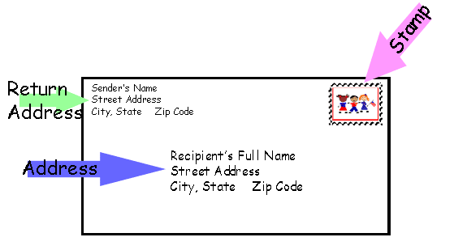  
**After requesting an upload in SchooLinks:**   
Kindly remind the teacher when the due date is near.   
Write a thank you note to the teacher even if you’re not accepted to the university   
Let the teacher who wrote you a rec letter know where you are planning on attending.

Alaine Butz  
5550 Dulles Ave  
Sugar Land TX 77478

The office of Admissions  
One Bear Place 97056  
Waco, TX 76798-7056

**How to address an envelope:**