Ms.Garza  
Work Number:   
emma.garza[@fortbendisd.com](mailto:Richard.embrick@fortbendisd.com)  
  
**Conference Period:  7th Period**  
  
Welcome to David Crockett Middle School STEM program. This class is “activity oriented” to show students how **technology** is used in robotics & engineering to solve everyday problems and is designed to spark an interest in STEM subjects as well as prepare students for further study in high school. This course is heavy in Science and Math concepts and students should show an interest in these advanced studies.

**Required for course:**

Robotics & Engineering I

Engineering notebook: Composition or otherwise and a pencil/pen DAILY. Composition notebooks may be left in the room. Notebooks are part of the Engineering grade throughout the course.

Robotics & Engineering II

Engineering notebook: Composition or otherwise and a pencil/pen DAILY. Composition notebooks may be left in the room. Notebooks are part of the Engineering grade throughout the course.

**Field experience (Field Trips) and cost: TBD**

** Students must maintain passing grades, exhibit traits of a model maverick, and have no serous behavior infractions in order to participate in ANY/ALL extracurricular activities (Field experiences/Field Trips).

**Important information**  
  
It is ***EXTREMELY VITAL*** that students DO NOT miss class when possible. As a project-based class, students will miss valuable lab experiences when not present.

**\*\* Please check Schoology and Skyward for student missing work and teacher feedback. We will always refer you back to Schoology and Skyward when looking for missing assignments.**

**Below is an example of a weekly calendar in Schoology that allows students and parents to see daily assignments and past graded assignments.**

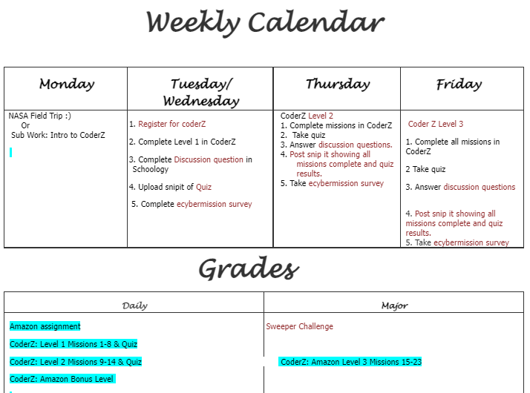

**GRADING RUBRIC**

**The official gradebook is Skyward. Not all grades in Schoology will be reported to Skyward. Also, teachers may take a grade that is from an activity that does not appear in the Schoology gradebook (Flipgrid activities, etc.).**

Major Grades: 50% of the grading period average (Projects and Presentations)

Daily Grades: 50% of the grading period average (Activities, written assignments, problems)

Check for Understanding: Assignments in Schoology or other online platforms that help students with feedback leading up to major/daily grades.

**LATE WORK POLICY**

Students will be allowed to submit late work. Late work must be submitted before the last week of the reporting period before progress reports and the final report card. Late work will result in grade penalties. Campus guidelines are as follows:

- 6th Graders will receive 10 points off for each day an assignment is late.

- 7th and 8th Graders will receive 20 points off after one day, 30 points off for two days late, and/or a maximum grade of 50 for three or more days late

**PARENT SUPPORT**

Parents will have access to support materials, class information, calendar, and assignments. found in Schoology. Parents can check Skyward for current student grades.

**CLASSROOM EXPECTATIONS/ROUTINES**

Students will exhibit Care, Commitment, and Trust towards each other, the teacher and the classroom and equipment. Students will follow the safety guidelines when using tools as signed by each student.

Respect Agreement:

Students co-created a respect agreement in the classroom. The respect agreement has 4 categories: Students respecting students, students respecting teacher, teacher respecting students, and students respecting facilities/ classroom equipment. We as a class shared, signed, and posted the class expectations to refer to for the year. Students were able to share expectations and be heard to establish what they need to be successful in the classroom. It is important for students and teachers to uphold the agreement to ensure the best learning environment for all students.

