Human Heredity
- _________________ copies of each autosomal gene affect phenotype.
- Mendel studied _____________________________ gene traits, like hair texture.

Beyond dominant and recessive alleles
- Some alleles are neither dominant nor recessive.
____________________________________________:
- situation in which one allele is not completely dominant over another; the phenotype is a “_____________________________” of the two alleles
  - Example: In some plants, when a true-breeding plant with red flowers is crossed with a true-breeding plant with white flowers, pink flowers are produced. Neither red nor white is dominant over the other.
- Phenotype can depend on interactions of alleles.
- In incomplete dominance, neither allele is completely dominant nor completely recessive.
  - Heterozygous phenotype is intermediate between the two homozygous phenotypes
  - Homozygous parental phenotypes not seen in F₁ offspring
______________________________________:
- situation in which both alleles of a gene contribute to the phenotype of the organism; ________________ alleles are expressed but NOT blended
  - Example: In cows, the allele for red fur is codominant with the allele for white fur. Heterozygous cows carrying one red and one white allele have spotted fur, known as roan.
- Codominant alleles will both be _____________________________________________________.

Many traits are controlled by multiple alleles or multiple genes.
  - _____________________________ (more than 2 choices)
  - _____________________________(multiple genes control a single trait)

___________________________: the case where three or more alleles of the same gene exist. Remember, an organism will have only two of these alleles (one from mom and one from dad).
  - Examples: Coat color in rabbits, blood type in humans
Polygenic traits:
- traits that are determined by alleles from more than one gene; these traits usually have a range of phenotypes
  - Examples: skin color in humans, height in humans
- Many genes may interact to produce one trait.
- Polygenic traits are produced by two or more genes.

Human chromosomes
- Most of our cells contain _______ pairs of chromosomes, for a total of _______ chromosomes.
  - These cells are called _____________ cells or _____________ cells.
  - Two exceptions are the _____________ (sex cells), sperm and eggs, which have _______ copy of each chromosome. Sperm and egg cells each have _______ chromosomes.
- There are two types of chromosomes.
  - __________________________: Of the 46 chromosomes, 44 of them (_____________ of chromosomes) are called __________________________ (non-sex chromosomes).
  - __________________________: The last two chromosomes are called the _____________ chromosomes because they determine the sex of the person. Females have two ______ chromosomes (XX) and males have one ______ and one ______ chromosome (XY).
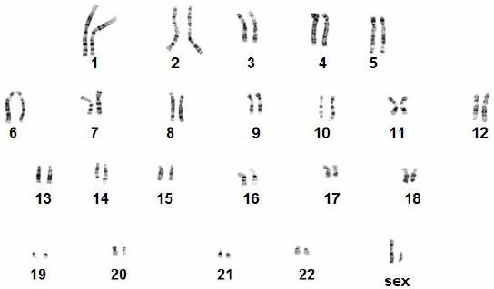
- Scientists can analyze chromosomes by taking a picture of cells during ______________. It is easiest to view chromosomes during mitosis because they are condensed. From a picture of ___________________, scientists can cut and paste to arrange the chromosomes in pairs to form a _____________________. They are arranged from ______________ (pair #1) to __________________ (pair #22). The last pair (#______) is the ______ chromosomes.

Too many = Trisomy ___
Too few = monosomy ____
If there is a Y it is male, no matter how many X’s
Only X it is a female

Human Traits: Pedigrees
- A ______________ is similar to a family tree- both are used to show relationships in a family.
- Pedigrees can be used to demonstrate how ___________ are passed from one generation to another.
- Genetic counselors use pedigrees to follow how genetic disorders are ______________.
- People who are _____________________for a recessive genetic disorder (they are unaffected) are called _____________________.
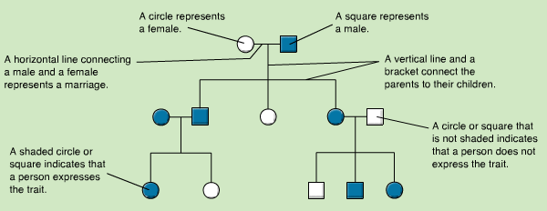

Human Genes: Blood typing
In humans, blood type is determined by the _______ blood group and the _______ blood group.
- The Rh blood group determines if your blood is ______________ or negative.
  - There are two Rh alleles: the Rh⁺ allele is ______________ to the Rh⁻ allele.
  - Your blood is ___________ if you are Rh⁺/Rh⁺ or Rh⁺/Rh⁻. Your blood is ___________ if you are Rh⁻ /Rh⁻
- The ABO group is more complicated. There are _______ alleles: I^{A}, I^{B}, and i.
  - The I^{A} and I^{B} alleles are _____________________. The I^{A} and I^{B} alleles cause expression of carbohydrate chains called ___________________ on surface of red blood cells. They help your body ___________________ the cells.
  - The i allele is ___________________ to the other two alleles. The i allele O does _______ produce antigens.
  - The ABO blood group is important in blood ____________________________________.
    - If the blood recipient has never been exposed to an antigen (A or B) and that _________________ enters the body it will cause an __________________ reaction. This can cause _____________.
    - In emergency rooms when there isn’t time to figure out the blood type of the patient, which type of blood will the patient receive? __________ because these cells have no _________________ antigens. People with Type O blood are called universal _________.
    - Who is the universal recipient that can receive blood from any donor? _____________.

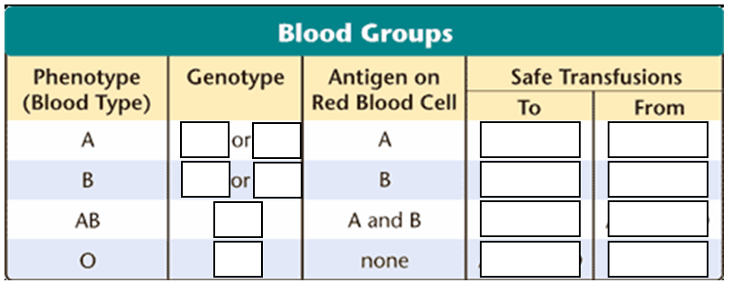

Most genetic disorders are caused by mutations on ______________, or non-sex chromosomes.
Examples include:
- ____________________________ disorders: albinism, cystic fibrosis, Tay-Sachs disease
- ____________________________ disorders: most common form of dwarfism (achondroplasia) and Hypercholesterolemia (high cholesterol)
- ______________ disorders: sickle-cell disease
Some genetic disorders are caused be genes on the _______ chromosomes.
- Most of these genes are on the _______ chromosome because the Y chromosome is very small and has few _______. The genes on the X chromosome are _____________ from genes on the Y chromosome.
- Because females are XX they have _______ copies of the genes on the X chromosome. For sex-linked traits, females can be homozygous __________________________, __________________________, or homozygous __________________________.
- Because males are _______ they have only _______ copy of the genes on the X chromosome. In males, only _______ recessive allele on the X chromosome is necessary for the recessive phenotype to be expressed because there is _______ another allele for this gene on the Y chromosome. Some sex-linked (also known as ______________) genetic conditions include:
  - ____________________________ - the inability to distinguish certain colors
  - ____________________________ - missing protein important for blood clotting
  - Duchenne Muscular Dystrophy- progressive weakening of ____________________________

Example of a sex-linked Punnett square:
X^{B} X^{b} (heterozygous female with normal vision) crossed to X^{B}Y (hemizygous male with normal vision).
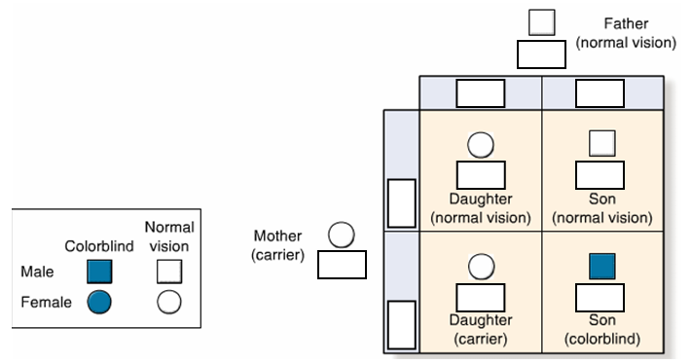

Chromosomal Disorders
Remember that meiosis is the reductional cell ______________ that divides one diploid cell to produce two ______________ gametes (sex cells, sperm or egg). Normally gametes have _______ copy of each chromosome.
- Sometimes chromosomes might not separate properly during meiosis; this is called _________________________________.
- If nondisjunction occurs, ______________ numbers of chromosomes (usually one is ______________ or there is an ______________ copy of one) are found in gametes and disorders of chromosomal numbers may result.
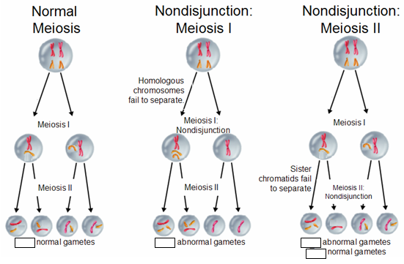
- ____________________________: Some chromosomal disorders are caused by having _______ copies of one chromosome. This is called ______________. In trisomies, the gamete of one parent donated _______chromosomes to the child and the gamete of the other parent donated _______ chromosome (like __________)
- ____________________________: Chromosomal disorders characterized by ______________ one chromosome are called monosomies. In _____________________, the gamete of one parent donated one chromosome and the other did ______________donate any.
Some examples of chromosomal disorders resulting from ____________________________:
- Down syndrome- _____________________
- Klinefelter’s syndrome- _____________________
- Turner’s syndrome- _____________________
Human Genome Project
The human genome project sequenced the human ______________. Now the code is being analyzed and scientists are finding ____________ for many traits and genetic disorders. In gene ______________, a gene that has been mutated and doesn’t work properly is replaced by a ______________, working copy of the gene. Gene therapy is a work in progress

